VSPERF Design
OPNFV
March 05, 2016
[index::doc]

VSPERF Design Document
[vswitchperf_{d}esign:vsperf-design-document][vswitchperf_{d}esign::doc][vswitchperf_{d}esign:vsperf-design]

Intended Audience
[vswitchperf_{d}esign:intended-audience] This document is intended to aid those who want to modify the vsperf code. Or to extend it - for example to add support for new traffic generators, deployment scenarios and so on.

Usage
[vswitchperf_{d}esign:usage]

Example Connectivity to DUT
[vswitchperf_{d}esign:example-connectivity-to-dut] Establish connectivity to the VSPERF DUT Linux host, such as the DUT in Pod 3, by following the steps in Testbed POD3
The steps cover booking the DUT and establishing the VSPERF environment.

Example Command Lines
[vswitchperf_{d}esign:example-command-lines] List all the cli options:
\PYG{g+gp}{\PYGZdl{}} ./vsperf \PYGZhy{}h
Run all tests that have in their name - , etc.:
\PYG{g+gp}{\PYGZdl{}} ./vsperf \PYGZhy{}\PYGZhy{}tests \PYG{l+s+s1}{\PYGZsq{}tput\PYGZsq{}}
As above but override default configuration with settings in ‘10_custom.conf’. This is useful as modifying configuration directly in the configuration files in shows up as changes under git source control:
\PYG{g+gp}{\PYGZdl{}} ./vsperf \PYGZhy{}\PYGZhy{}conf\PYGZhy{}file\PYG{o}{=}\PYGZlt{}path\PYGZus{}to\PYGZus{}custom\PYGZus{}conf\PYGZgt{}/10\PYGZus{}custom.conf \PYGZhy{}\PYGZhy{}tests \PYG{l+s+s1}{\PYGZsq{}tput\PYGZsq{}}
Override specific test parameters. Useful for shortening the duration of tests for development purposes:
\PYG{g+gp}{\PYGZdl{}} ./vsperf \PYGZhy{}\PYGZhy{}test\PYGZhy{}params \PYG{l+s+s1}{\PYGZsq{}duration=10;rfc2544\PYGZus{}trials=1;pkt\PYGZus{}sizes=64\PYGZsq{}} \PYGZhy{}\PYGZhy{}tests \PYG{l+s+s1}{\PYGZsq{}pvp\PYGZus{}tput\PYGZsq{}}

Typical Test Sequence
[vswitchperf_{d}esign:typical-test-sequence] This is a typical flow of control for a test.
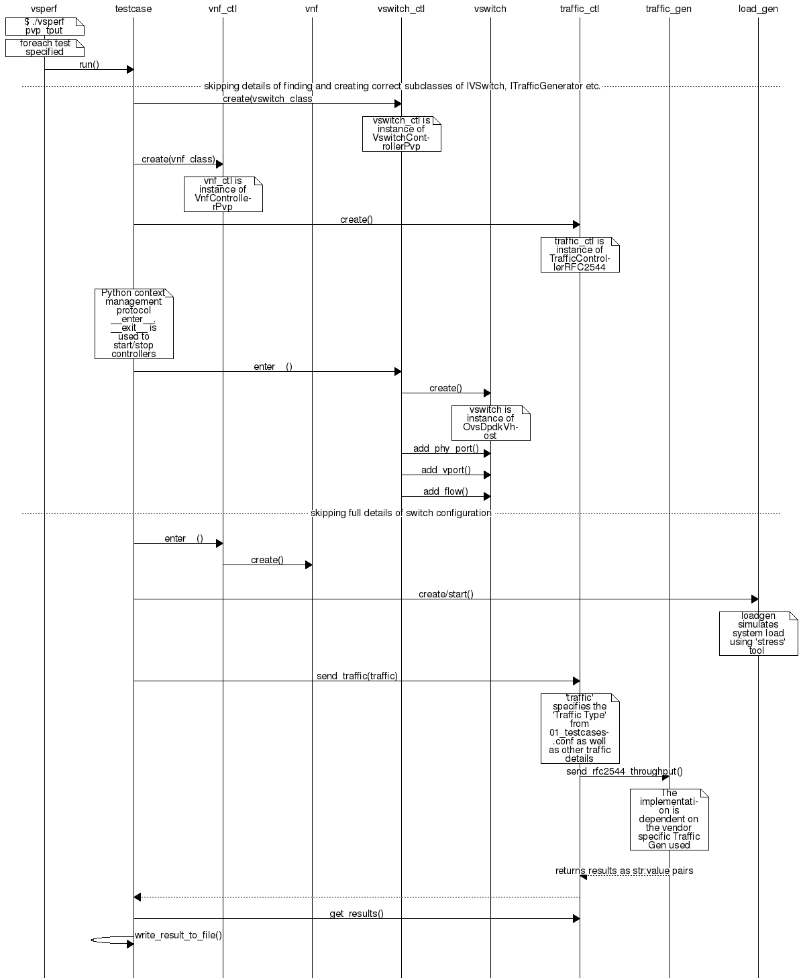

Configuration
[vswitchperf_{d}esign:configuration] The conf package contains the configuration files () for all system components, it also provides a object that exposes all of these settings.
Settings are not passed from component to component. Rather they are available globally to all components once they import the conf package.
\PYG{k+kn}{from} \PYG{n+nn}{conf} \PYG{k+kn}{import} \PYG{n}{settings}
\PYG{o}{.}\PYG{o}{.}\PYG{o}{.}
\PYG{n}{log\PYGZus{}file} \PYG{o}{=} \PYG{n}{settings}\PYG{o}{.}\PYG{n}{getValue}\PYG{p}{(}\PYG{l+s}{\PYGZsq{}}\PYG{l+s}{LOG\PYGZus{}FILE\PYGZus{}DEFAULT}\PYG{l+s}{\PYGZsq{}}\PYG{p}{)}
Settings files () are valid python code so can be set to complex types such as lists and dictionaries as well as scalar types:
\PYG{n}{first\PYGZus{}packet\PYGZus{}size} \PYG{o}{=} \PYG{n}{settings}\PYG{o}{.}\PYG{n}{getValue}\PYG{p}{(}\PYG{l+s}{\PYGZsq{}}\PYG{l+s}{PACKET\PYGZus{}SIZE\PYGZus{}LIST}\PYG{l+s}{\PYGZsq{}}\PYG{p}{)}\PYG{p}{[}\PYG{l+m+mi}{0}\PYG{p}{]}

Configuration Procedure and Precedence
[vswitchperf_{d}esign:configuration-procedure-and-precedence] Configuration files follow a strict naming convention that allows them to be processed in a specific order. All the .conf files are named , where NN is a decimal number. The files are processed in order from 00_name.conf to 99_name.conf so that if the name setting is given in both a lower and higher numbered conf file then the higher numbered file is the effective setting as it is processed after the setting in the lower numbered file.
The values in the file specified by takes precedence over all the other configuration files and does not have to follow the naming convention.

Other Configuration
[vswitchperf_{d}esign:other-configuration] also loads configuration from the command line and from the environment.

VM, vSwitch, Traffic Generator Independence
[vswitchperf_{d}esign:vm-vswitch-traffic-generator-independence] VSPERF supports different vSwithes, Traffic Generators, VNFs and Forwarding Applications by using standard object-oriented polymorphism:
- Support for vSwitches is implemented by a class inheriting from IVSwitch.
- Support for Traffic Generators is implemented by a class inheriting from ITrafficGenerator.
- Support for VNF is implemented by a class inheriting from IVNF.
- Support for Forwarding Applications is implemented by a class inheriting from IPktFwd.
By dealing only with the abstract interfaces the core framework can support many implementations of different vSwitches, Traffic Generators, VNFs and Forwarding Applications.

IVSwitch
[vswitchperf_{d}esign:ivswitch]
\PYG{k}{class} \PYG{n+nc}{IVSwitch}\PYG{p}{:}
\PYG{n}{start}\PYG{p}{(}\PYG{n+nb+bp}{self}\PYG{p}{)}
\PYG{n}{stop}\PYG{p}{(}\PYG{n+nb+bp}{self}\PYG{p}{)}
\PYG{n}{add\PYGZus{}switch}\PYG{p}{(}\PYG{n}{switch\PYGZus{}name}\PYG{p}{)}
\PYG{n}{del\PYGZus{}switch}\PYG{p}{(}\PYG{n}{switch\PYGZus{}name}\PYG{p}{)}
\PYG{n}{add\PYGZus{}phy\PYGZus{}port}\PYG{p}{(}\PYG{n}{switch\PYGZus{}name}\PYG{p}{)}
\PYG{n}{add\PYGZus{}vport}\PYG{p}{(}\PYG{n}{switch\PYGZus{}name}\PYG{p}{)}
\PYG{n}{get\PYGZus{}ports}\PYG{p}{(}\PYG{n}{switch\PYGZus{}name}\PYG{p}{)}
\PYG{n}{del\PYGZus{}port}\PYG{p}{(}\PYG{n}{switch\PYGZus{}name}\PYG{p}{,} \PYG{n}{port\PYGZus{}name}\PYG{p}{)}
\PYG{n}{add\PYGZus{}flow}\PYG{p}{(}\PYG{n}{switch\PYGZus{}name}\PYG{p}{,} \PYG{n}{flow}\PYG{p}{)}
\PYG{n}{del\PYGZus{}flow}\PYG{p}{(}\PYG{n}{switch\PYGZus{}name}\PYG{p}{,} \PYG{n}{flow}\PYG{o}{=}\PYG{n+nb+bp}{None}\PYG{p}{)}

ITrafficGenerator
[vswitchperf_{d}esign:itrafficgenerator]
\PYG{k}{class} \PYG{n+nc}{ITrafficGenerator}\PYG{p}{:}
\PYG{n}{connect}\PYG{p}{(}\PYG{p}{)}
\PYG{n}{disconnect}\PYG{p}{(}\PYG{p}{)}

\PYG{n}{send\PYGZus{}burst\PYGZus{}traffic}\PYG{p}{(}\PYG{n}{traffic}\PYG{p}{,} \PYG{n}{numpkts}\PYG{p}{,} \PYG{n}{time}\PYG{p}{,} \PYG{n}{framerate}\PYG{p}{)}

\PYG{n}{send\PYGZus{}cont\PYGZus{}traffic}\PYG{p}{(}\PYG{n}{traffic}\PYG{p}{,} \PYG{n}{time}\PYG{p}{,} \PYG{n}{framerate}\PYG{p}{)}
\PYG{n}{start\PYGZus{}cont\PYGZus{}traffic}\PYG{p}{(}\PYG{n}{traffic}\PYG{p}{,} \PYG{n}{time}\PYG{p}{,} \PYG{n}{framerate}\PYG{p}{)}
\PYG{n}{stop\PYGZus{}cont\PYGZus{}traffic}\PYG{p}{(}\PYG{n+nb+bp}{self}\PYG{p}{)}\PYG{p}{:}

\PYG{n}{send\PYGZus{}rfc2544\PYGZus{}throughput}\PYG{p}{(}\PYG{n}{traffic}\PYG{p}{,} \PYG{n}{trials}\PYG{p}{,} \PYG{n}{duration}\PYG{p}{,} \PYG{n}{lossrate}\PYG{p}{)}
\PYG{n}{start\PYGZus{}rfc2544\PYGZus{}throughput}\PYG{p}{(}\PYG{n}{traffic}\PYG{p}{,} \PYG{n}{trials}\PYG{p}{,} \PYG{n}{duration}\PYG{p}{,} \PYG{n}{lossrate}\PYG{p}{)}
\PYG{n}{wait\PYGZus{}rfc2544\PYGZus{}throughput}\PYG{p}{(}\PYG{n+nb+bp}{self}\PYG{p}{)}

\PYG{n}{send\PYGZus{}rfc2544\PYGZus{}back2back}\PYG{p}{(}\PYG{n}{traffic}\PYG{p}{,} \PYG{n}{trials}\PYG{p}{,} \PYG{n}{duration}\PYG{p}{,} \PYG{n}{lossrate}\PYG{p}{)}
\PYG{n}{start\PYGZus{}rfc2544\PYGZus{}back2back}\PYG{p}{(}\PYG{n}{traffic}\PYG{p}{,} \PYG{p}{,} \PYG{n}{trials}\PYG{p}{,} \PYG{n}{duration}\PYG{p}{,} \PYG{n}{lossrate}\PYG{p}{)}
\PYG{n}{wait\PYGZus{}rfc2544\PYGZus{}back2back}\PYG{p}{(}\PYG{p}{)}
Note blocks whereas does not and must be followed by a subsequent call to .

IVnf
[vswitchperf_{d}esign:ivnf]
\PYG{k}{class} \PYG{n+nc}{IVnf}\PYG{p}{:}
\PYG{n}{start}\PYG{p}{(}\PYG{n}{memory}\PYG{p}{,} \PYG{n}{cpus}\PYG{p}{,}
\PYG{n}{monitor\PYGZus{}path}\PYG{p}{,} \PYG{n}{shared\PYGZus{}path\PYGZus{}host}\PYG{p}{,}
\PYG{n}{shared\PYGZus{}path\PYGZus{}guest}\PYG{p}{,} \PYG{n}{guest\PYGZus{}prompt}\PYG{p}{)}
\PYG{n}{stop}\PYG{p}{(}\PYG{p}{)}
\PYG{n}{execute}\PYG{p}{(}\PYG{n}{command}\PYG{p}{)}
\PYG{n}{wait}\PYG{p}{(}\PYG{n}{guest\PYGZus{}prompt}\PYG{p}{)}
\PYG{n}{execute\PYGZus{}and\PYGZus{}wait} \PYG{p}{(}\PYG{n}{command}\PYG{p}{)}

IPktFwd
[vswitchperf_{d}esign:ipktfwd]
\PYG{k}{class} \PYG{n+nc}{IPktFwd}\PYG{p}{:}
\PYG{n}{start}\PYG{p}{(}\PYG{p}{)}
\PYG{n}{stop}\PYG{p}{(}\PYG{p}{)}

Controllers
[vswitchperf_{d}esign:controllers] Controllers are used in conjunction with abstract interfaces as way of decoupling the control of vSwtiches, VNFs, TrafficGenerators and Forwarding Applications from other components.
The controlled classes provide basic primitive operations. The Controllers sequence and co-ordinate these primitive operation in to useful actions. For instance the vswitch_controller_PVP can be used to bring any vSwitch (that implements the primitives defined in IVSwitch) into the configuration required by the Phy-to-Phy Deployment Scenario.
In order to support a new vSwitch only a new implementation of IVSwitch needs be created for the new vSwitch to be capable of fulfilling all the Deployment Scenarios provided for by existing or future vSwitch Controllers.
Similarly if a new Deployment Scenario is required it only needs to be written once as a new vSwitch Controller and it will immediately be capable of controlling all existing and future vSwitches in to that Deployment Scenario.
Similarly the Traffic Controllers can be used to co-ordinate basic operations provided by implementers of ITrafficGenerator to provide useful tests. Though traffic generators generally already implement full test cases i.e. they both generate suitable traffic and analyse returned traffic in order to implement a test which has typically been predefined in an RFC document. However the Traffic Controller class allows for the possibility of further enhancement - such as iterating over tests for various packet sizes or creating new tests.

Traffic Controller’s Role
[vswitchperf_{d}esign:traffic-controller-s-role] 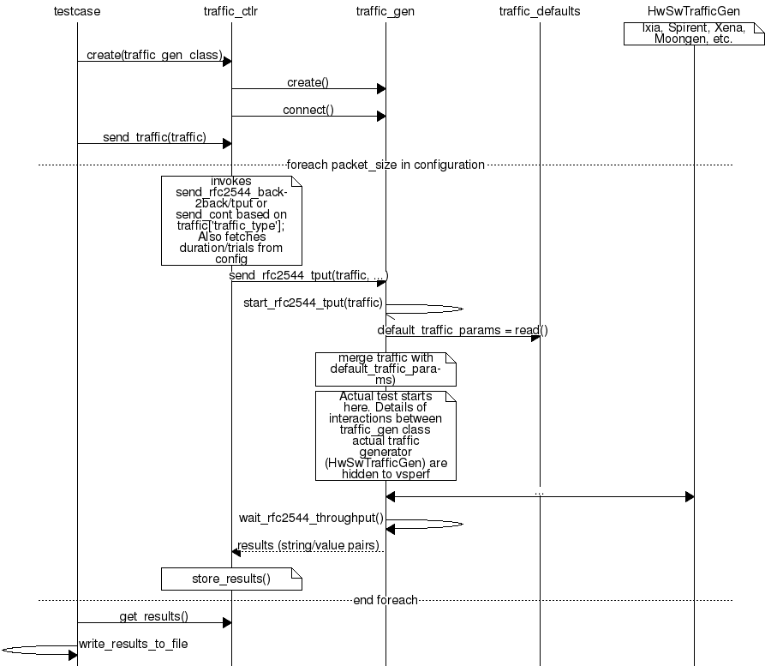

Loader & Component Factory
[vswitchperf_{d}esign:loader-component-factory] The working of the Loader package (which is responsible for finding arbitrary classes based on configuration data) and the Component Factory which is responsible for choosing the correct class for a particular situation - e.g. Deployment Scenario can be seen in this diagram.
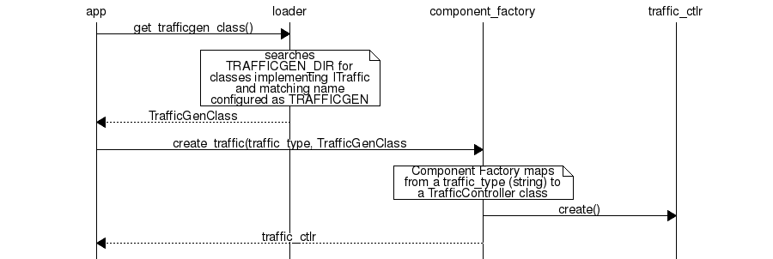

Routing Tables
[vswitchperf_{d}esign:routing-tables] Vsperf uses a standard set of routing tables in order to allow tests to easily mix and match Deployment Scenarios (PVP, P2P topology), Tuple Matching and Frame Modification requirements.
\PYG{g+go}{+\PYGZhy{}\PYGZhy{}\PYGZhy{}\PYGZhy{}\PYGZhy{}\PYGZhy{}\PYGZhy{}\PYGZhy{}\PYGZhy{}\PYGZhy{}\PYGZhy{}\PYGZhy{}\PYGZhy{}\PYGZhy{}+}
\PYG{g+go}{\textbar{} \textbar{}}
\PYG{g+go}{\textbar{} Table 0 \textbar{} table\PYGZsh{}0 \PYGZhy{} Match table. Flows designed to force 5 \PYGZam{} 10}
\PYG{g+go}{\textbar{} \textbar{} tuple matches go here.}
\PYG{g+go}{\textbar{} \textbar{}}
\PYG{g+go}{+\PYGZhy{}\PYGZhy{}\PYGZhy{}\PYGZhy{}\PYGZhy{}\PYGZhy{}\PYGZhy{}\PYGZhy{}\PYGZhy{}\PYGZhy{}\PYGZhy{}\PYGZhy{}\PYGZhy{}\PYGZhy{}+}
\PYG{g+go}{ \textbar{}}
\PYG{g+go}{ \textbar{}}
\PYG{g+go}{ v}
\PYG{g+go}{+\PYGZhy{}\PYGZhy{}\PYGZhy{}\PYGZhy{}\PYGZhy{}\PYGZhy{}\PYGZhy{}\PYGZhy{}\PYGZhy{}\PYGZhy{}\PYGZhy{}\PYGZhy{}\PYGZhy{}\PYGZhy{}+ table\PYGZsh{}1 \PYGZhy{} Routing table. Flow entries to forward}
\PYG{g+go}{\textbar{} \textbar{} packets between ports goes here.}
\PYG{g+go}{\textbar{} Table 1 \textbar{} The chosen port is communicated to subsequent tables by}
\PYG{g+go}{\textbar{} \textbar{} setting the metadata value to the egress port number.}
\PYG{g+go}{\textbar{} \textbar{} Generally this table is set\PYGZhy{}up by by the}
\PYG{g+go}{+\PYGZhy{}\PYGZhy{}\PYGZhy{}\PYGZhy{}\PYGZhy{}\PYGZhy{}\PYGZhy{}\PYGZhy{}\PYGZhy{}\PYGZhy{}\PYGZhy{}\PYGZhy{}\PYGZhy{}\PYGZhy{}+ vSwitchController.}
\PYG{g+go}{ \textbar{}}
\PYG{g+go}{ \textbar{}}
\PYG{g+go}{ v}
\PYG{g+go}{+\PYGZhy{}\PYGZhy{}\PYGZhy{}\PYGZhy{}\PYGZhy{}\PYGZhy{}\PYGZhy{}\PYGZhy{}\PYGZhy{}\PYGZhy{}\PYGZhy{}\PYGZhy{}\PYGZhy{}\PYGZhy{}+ table\PYGZsh{}2 \PYGZhy{} Frame modification table. Frame modification}
\PYG{g+go}{\textbar{} \textbar{} flow rules are isolated in this table so that they can}
\PYG{g+go}{\textbar{} Table 2 \textbar{} be turned on or off without affecting the routing or}
\PYG{g+go}{\textbar{} \textbar{} tuple\PYGZhy{}matching flow rules. This allows the frame}
\PYG{g+go}{\textbar{} \textbar{} modification and tuple matching required by the tests}
\PYG{g+go}{\textbar{} \textbar{} in the VSWITCH PERFORMANCE FOR TELCO NFV test}
\PYG{g+go}{+\PYGZhy{}\PYGZhy{}\PYGZhy{}\PYGZhy{}\PYGZhy{}\PYGZhy{}\PYGZhy{}\PYGZhy{}\PYGZhy{}\PYGZhy{}\PYGZhy{}\PYGZhy{}\PYGZhy{}\PYGZhy{}+ specification to be independent of the Deployment}
\PYG{g+go}{ \textbar{} Scenario set up by the vSwitchController.}
\PYG{g+go}{ \textbar{}}
\PYG{g+go}{ v}
\PYG{g+go}{+\PYGZhy{}\PYGZhy{}\PYGZhy{}\PYGZhy{}\PYGZhy{}\PYGZhy{}\PYGZhy{}\PYGZhy{}\PYGZhy{}\PYGZhy{}\PYGZhy{}\PYGZhy{}\PYGZhy{}\PYGZhy{}+}
\PYG{g+go}{\textbar{} \textbar{}}
\PYG{g+go}{\textbar{} Table 3 \textbar{} table\PYGZsh{}3 \PYGZhy{} Egress table. Egress packets on the ports}
\PYG{g+go}{\textbar{} \textbar{} setup in Table 1.}
\PYG{g+go}{+\PYGZhy{}\PYGZhy{}\PYGZhy{}\PYGZhy{}\PYGZhy{}\PYGZhy{}\PYGZhy{}\PYGZhy{}\PYGZhy{}\PYGZhy{}\PYGZhy{}\PYGZhy{}\PYGZhy{}\PYGZhy{}+}

Traffic Generator Integration Guide
[trafficgen_{i}ntegration_{g}uide::doc][trafficgen_{i}ntegration_{g}uide:traffic-generator-integration-guide]

Intended Audience
[trafficgen_{i}ntegration_{g}uide:intended-audience] This document is intended to aid those who want to integrate new traffic generator into the vsperf code. It is expected, that reader has already read generic part of VSPERF Design Document.
Let us create a sample traffic generator called sample_tg, step by step.

Step 1 - create a directory
[trafficgen_{i}ntegration_{g}uide:step-1-create-a-directory] Implementation of trafficgens is located at tools/pkt_gen/ directory, where every implementation has its dedicated sub-directory. It is required to create a new directory for new traffic generator implementations.
E.g.
\PYG{g+gp}{\PYGZdl{}} mkdir tools/pkt\PYGZus{}gen/sample\PYGZus{}tg

Step 2 - create a trafficgen module
[trafficgen_{i}ntegration_{g}uide:step-2-create-a-trafficgen-module] Every trafficgen class must inherit from generic ITrafficGenerator interface class. VSPERF during its initialization scans content of pkt_gen directory for all python modules, that inherit from ITrafficGenerator. These modules are automatically added into the list of supported traffic generators.
Example:
Let us create a draft of tools/pkt_gen/sample_tg/sample_tg.py module.
\PYG{k+kn}{from} \PYG{n+nn}{tools.pkt\PYGZus{}gen} \PYG{k+kn}{import} \PYG{n}{trafficgen}

\PYG{k}{class} \PYG{n+nc}{SampleTG}\PYG{p}{(}\PYG{n}{trafficgen}\PYG{o}{.}\PYG{n}{ITrafficGenerator}\PYG{p}{)}\PYG{p}{:}
\PYG{l+s+sd}{\PYGZdq{}\PYGZdq{}\PYGZdq{}}
\PYG{l+s+sd}{ A sample traffic generator implementation}
\PYG{l+s+sd}{ \PYGZdq{}\PYGZdq{}\PYGZdq{}}
\PYG{k}{pass}
VSPERF is immediately aware of the new class:
\PYG{g+gp}{\PYGZdl{}} ./vsperf \PYGZhy{}\PYGZhy{}list\PYGZhy{}trafficgen
Output should look like:
\PYG{g+go}{Classes derived from: ITrafficGenerator}
\PYG{g+go}{======}

\PYG{g+go}{* Ixia: A wrapper around the IXIA traffic generator.}

\PYG{g+go}{* IxNet: A wrapper around IXIA IxNetwork applications.}

\PYG{g+go}{* Dummy: A dummy traffic generator whose data is generated by the user.}

\PYG{g+go}{* SampleTG: A sample traffic generator implementation}

\PYG{g+go}{* TestCenter: Spirent TestCenter}

Step 3 - configuration
[trafficgen_{i}ntegration_{g}uide:step-3-configuration] All configuration values, required for correct traffic generator function, are passed from VSPERF to the traffic generator in a dictionary. Default values shared among all traffic generators are defined in tools/pkt_gen/trafficgen/trafficgenhelper.py as TRAFFIC_DEFAULTS dictionary. Default values are loaded by ITrafficGenerator interface class automatically, so it is not needed to load them explicitly. In case that there are any traffic generator specific default values, then they should be set within class specific __init__ function.
VSPERF passes test specific configuration within traffic dictionary to every start and send function. So implementation of these functions must ensure, that default values are updated with the testcase specific values. Proper merge of values is assured by call of merge_spec function from trafficgenhelper module.
Example of merge_spec usage in tools/pkt_gen/sample_tg/sample_tg.py module:
\PYG{k+kn}{from} \PYG{n+nn}{tools.pkt\PYGZus{}gen.trafficgen.trafficgenhelper} \PYG{k+kn}{import} \PYG{n}{merge\PYGZus{}spec}

\PYG{k}{def} \PYG{n+nf}{start\PYGZus{}rfc2544\PYGZus{}throughput}\PYG{p}{(}\PYG{n+nb+bp}{self}\PYG{p}{,} \PYG{n}{traffic}\PYG{o}{=}\PYG{n+nb+bp}{None}\PYG{p}{,} \PYG{n}{duration}\PYG{o}{=}\PYG{l+m+mi}{30}\PYG{p}{)}\PYG{p}{:}
\PYG{n+nb+bp}{self}\PYG{o}{.}\PYG{n}{\PYGZus{}params} \PYG{o}{=} \PYG{p}{\PYGZob{}}\PYG{p}{\PYGZcb{}}
\PYG{n+nb+bp}{self}\PYG{o}{.}\PYG{n}{\PYGZus{}params}\PYG{p}{[}\PYG{l+s}{\PYGZsq{}}\PYG{l+s}{traffic}\PYG{l+s}{\PYGZsq{}}\PYG{p}{]} \PYG{o}{=} \PYG{n+nb+bp}{self}\PYG{o}{.}\PYG{n}{traffic\PYGZus{}defaults}\PYG{o}{.}\PYG{n}{copy}\PYG{p}{(}\PYG{p}{)}
\PYG{k}{if} \PYG{n}{traffic}\PYG{p}{:}
\PYG{n+nb+bp}{self}\PYG{o}{.}\PYG{n}{\PYGZus{}params}\PYG{p}{[}\PYG{l+s}{\PYGZsq{}}\PYG{l+s}{traffic}\PYG{l+s}{\PYGZsq{}}\PYG{p}{]} \PYG{o}{=} \PYG{n}{trafficgen}\PYG{o}{.}\PYG{n}{merge\PYGZus{}spec}\PYG{p}{(}
\PYG{n+nb+bp}{self}\PYG{o}{.}\PYG{n}{\PYGZus{}params}\PYG{p}{[}\PYG{l+s}{\PYGZsq{}}\PYG{l+s}{traffic}\PYG{l+s}{\PYGZsq{}}\PYG{p}{]}\PYG{p}{,} \PYG{n}{traffic}\PYG{p}{)}

Step 4 - generic functions
[trafficgen_{i}ntegration_{g}uide:step-4-generic-functions] There are some generic functions, which every traffic generator should provide. Although these functions are mainly optional, at least empty implementation must be provided. This is required, so that developer is explicitly aware of these functions.
The connect function is called from the traffic generator controller from its __enter__ method. This function should assure proper connection initialization between DUT and traffic generator. In case, that such implementation is not needed, empty implementation is required.
The disconnect function should perform clean up of any connection specific actions called from the connect function.
Example in tools/pkt_gen/sample_tg/sample_tg.py module:
\PYG{k}{def} \PYG{n+nf}{connect}\PYG{p}{(}\PYG{n+nb+bp}{self}\PYG{p}{)}\PYG{p}{:}
\PYG{k}{pass}

\PYG{k}{def} \PYG{n+nf}{disconnect}\PYG{p}{(}\PYG{n+nb+bp}{self}\PYG{p}{)}\PYG{p}{:}
\PYG{k}{pass}

Step 5 - supported traffic types
[trafficgen_{i}ntegration_{g}uide:step-5-supported-traffic-types] Currently VSPERF supports three different types of tests for traffic generators, these are identified in vsperf through the traffic type, which include:
- RFC2544 throughput - Send fixed size packets at different rates, using
traffic configuration, until minimum rate at which no packet loss is detected is found. Methods with its implementation have suffix _rfc2544_throughput.
- RFC2544 back2back - Send fixed size packets at a fixed rate, using traffic
configuration, for specified time interval. Methods with its implementation have suffix _rfc2544_back2back.
- continuous flow - Send fixed size packets at given framerate, using traffic
configuration, for specified time interval. Methods with its implementation have suffix _cont_traffic.
In general, both synchronous and asynchronous interfaces must be implemented for each traffic type. Synchronous functions start with prefix send_. Asynchronous with prefixes start_ and wait_ in case of throughput and back2back and start_ and stop_ in case of continuous traffic type.
Example of synchronous interfaces:
\PYG{k}{def} \PYG{n+nf}{send\PYGZus{}rfc2544\PYGZus{}throughput}\PYG{p}{(}\PYG{n+nb+bp}{self}\PYG{p}{,} \PYG{n}{traffic}\PYG{o}{=}\PYG{n+nb+bp}{None}\PYG{p}{,} \PYG{n}{trials}\PYG{o}{=}\PYG{l+m+mi}{3}\PYG{p}{,} \PYG{n}{duration}\PYG{o}{=}\PYG{l+m+mi}{20}\PYG{p}{,}
\PYG{n}{lossrate}\PYG{o}{=}\PYG{l+m+mf}{0.0}\PYG{p}{,} \PYG{n}{multistream}\PYG{o}{=}\PYG{n+nb+bp}{False}\PYG{p}{)}\PYG{p}{:}
\PYG{k}{def} \PYG{n+nf}{send\PYGZus{}rfc2544\PYGZus{}back2back}\PYG{p}{(}\PYG{n+nb+bp}{self}\PYG{p}{,} \PYG{n}{traffic}\PYG{o}{=}\PYG{n+nb+bp}{None}\PYG{p}{,} \PYG{n}{trials}\PYG{o}{=}\PYG{l+m+mi}{1}\PYG{p}{,} \PYG{n}{duration}\PYG{o}{=}\PYG{l+m+mi}{20}\PYG{p}{,}
\PYG{n}{lossrate}\PYG{o}{=}\PYG{l+m+mf}{0.0}\PYG{p}{)}\PYG{p}{:}
\PYG{k}{def} \PYG{n+nf}{send\PYGZus{}cont\PYGZus{}traffic}\PYG{p}{(}\PYG{n+nb+bp}{self}\PYG{p}{,} \PYG{n}{traffic}\PYG{o}{=}\PYG{n+nb+bp}{None}\PYG{p}{,} \PYG{n}{duration}\PYG{o}{=}\PYG{l+m+mi}{20}\PYG{p}{,} \PYG{n}{multistream}\PYG{o}{=}\PYG{n+nb+bp}{False}\PYG{p}{)}\PYG{p}{:}
Example of asynchronous interfaces:
\PYG{k}{def} \PYG{n+nf}{start\PYGZus{}rfc2544\PYGZus{}throughput}\PYG{p}{(}\PYG{n+nb+bp}{self}\PYG{p}{,} \PYG{n}{traffic}\PYG{o}{=}\PYG{n+nb+bp}{None}\PYG{p}{,} \PYG{n}{trials}\PYG{o}{=}\PYG{l+m+mi}{3}\PYG{p}{,} \PYG{n}{duration}\PYG{o}{=}\PYG{l+m+mi}{20}\PYG{p}{,}
\PYG{n}{lossrate}\PYG{o}{=}\PYG{l+m+mf}{0.0}\PYG{p}{)}\PYG{p}{:}
\PYG{k}{def} \PYG{n+nf}{wait\PYGZus{}rfc2544\PYGZus{}throughput}\PYG{p}{(}\PYG{n+nb+bp}{self}\PYG{p}{)}\PYG{p}{:}

\PYG{k}{def} \PYG{n+nf}{start\PYGZus{}rfc2544\PYGZus{}back2back}\PYG{p}{(}\PYG{n+nb+bp}{self}\PYG{p}{,} \PYG{n}{traffic}\PYG{o}{=}\PYG{n+nb+bp}{None}\PYG{p}{,} \PYG{n}{trials}\PYG{o}{=}\PYG{l+m+mi}{1}\PYG{p}{,} \PYG{n}{duration}\PYG{o}{=}\PYG{l+m+mi}{20}\PYG{p}{,}
\PYG{n}{lossrate}\PYG{o}{=}\PYG{l+m+mf}{0.0}\PYG{p}{)}\PYG{p}{:}
\PYG{k}{def} \PYG{n+nf}{wait\PYGZus{}rfc2544\PYGZus{}back2back}\PYG{p}{(}\PYG{n+nb+bp}{self}\PYG{p}{)}\PYG{p}{:}

\PYG{k}{def} \PYG{n+nf}{start\PYGZus{}cont\PYGZus{}traffic}\PYG{p}{(}\PYG{n+nb+bp}{self}\PYG{p}{,} \PYG{n}{traffic}\PYG{o}{=}\PYG{n+nb+bp}{None}\PYG{p}{,} \PYG{n}{duration}\PYG{o}{=}\PYG{l+m+mi}{20}\PYG{p}{,} \PYG{n}{multistream}\PYG{o}{=}\PYG{n+nb+bp}{False}\PYG{p}{)}\PYG{p}{:}
\PYG{k}{def} \PYG{n+nf}{stop\PYGZus{}cont\PYGZus{}traffic}\PYG{p}{(}\PYG{n+nb+bp}{self}\PYG{p}{)}\PYG{p}{:}
Description of parameters used by send, start, wait and stop functions:
- param trials: Number of trials to execute
- param duration: Duration of continuous test or per iteration duration
in case of RFC2544 throughput or back2back traffic types.
- param lossrate: Acceptable lossrate percentage.
- param multistream: Enable or disable multistream feature.

Step 6 - passing back results
[trafficgen_{i}ntegration_{g}uide:step-6-passing-back-results] It is expected that methods send, wait and stop will return values measured by traffic generator within a dictionary. Dictionary keys are defined in ResultsConstants implemented in core/results/results_constants.py. Please check sections for RFC2544 Throughput & Continuous and for Back2Back. The same key names should be used by all traffic generator implementations.

