Promise Installation and Configuration Guide
OPNFV
February 25, 2016
[index::doc]

Promise Feature Configuration Overview
[featureconfig:promise-installation-and-configuration-guide][featureconfig:promise-feature-configuration-overview][featureconfig::doc]

Promise installation
[featureconfig:promise-installation] Install nodejs, npm and promise
curl \PYGZhy{}sL https://deb.nodesource.com/setup\PYGZus{}4.x \PYG{p}{\textbar{}} sudo \PYGZhy{}E bash \PYGZhy{}
sudo apt\PYGZhy{}get install \PYGZhy{}y nodejs
sudo npm \PYGZhy{}g install npm@latest
git clone https://github.com/opnfv/promise.git
\PYG{n+nb}{cd }promise
npm install
Please note that the last command ‘npm install’ will install all needed dependencies for promise (including yangforge and mocha)

Testing
[featureconfig:testing] Please perform the following preparation steps:
- Set OpenStack environment parameters properly (e.g. source openrc admin demo in DevStack)
- Create OpenStack tenant (e.g. promise) and tenant user (e.g. promiser)
- Create a flavor in Nova with 1 vCPU and 512 MB RAM
- Create a private network, subnet and router in Neutron
- Create an image in Glance
Once done, the promise test script can be invoked as follows (as a single line command):
\PYG{n+nv}{NODE\PYGZus{}ENV}\PYG{o}{=}mytest \PYG{l+s+se}{\PYGZbs{}}
\PYG{n+nv}{OS\PYGZus{}TENANT\PYGZus{}NAME}\PYG{o}{=}promise \PYG{l+s+se}{\PYGZbs{}}
\PYG{n+nv}{OS\PYGZus{}USERNAME}\PYG{o}{=}promiser \PYG{l+s+se}{\PYGZbs{}}
\PYG{n+nv}{OS\PYGZus{}PASSWORD}\PYG{o}{=}\PYGZlt{}user password from Step 2\PYGZgt{} \PYG{l+s+se}{\PYGZbs{}}
\PYG{n+nv}{OS\PYGZus{}TEST\PYGZus{}FLAVOR}\PYG{o}{=}\PYGZlt{}flavor ID from Step 3\PYGZgt{} \PYG{l+s+se}{\PYGZbs{}}
\PYG{n+nv}{OS\PYGZus{}TEST\PYGZus{}NETWORK}\PYG{o}{=}\PYGZlt{}network ID from Step 4\PYGZgt{} \PYG{l+s+se}{\PYGZbs{}}
\PYG{n+nv}{OS\PYGZus{}TEST\PYGZus{}IMAGE}\PYG{o}{=}\PYGZlt{}image ID from Step 5\PYGZgt{} \PYG{l+s+se}{\PYGZbs{}}
npm run \PYGZhy{}s \PYG{n+nb}{test} \PYGZhy{}\PYGZhy{} \PYGZhy{}\PYGZhy{}reporter json \PYGZgt{} promise\PYGZhy{}results.json
The results of the tests will be stored in the promise-results.json file.
The results can also be seen in the console (“npm run -s test”)
[htbp]
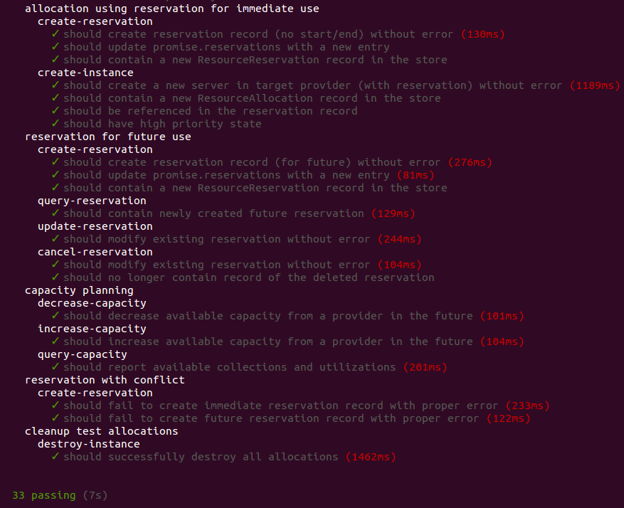 [featureconfig:figure1]
All 33 tests passing?! Congratulations, promise has been successfully installed and configured.

