Pharos Specification
OPNFV
February 09, 2016
[index::doc]

Objectives / Scope
[objectives:pharos-specification][objectives::doc][objectives:objectives-scope] The Pharos Specification defines a hardware environment for deployment and testing of the Brahmaputra platform release. The Pharos Project is also responsible for defining lab capabilities, developing management/usage policies and process; and a support plan for reliable access to project and release resources. Community labs are provided as a service by companies and are not controlled by Pharos however our objective is to provide easy visibility of all lab capabilities and their usage at all-times.
Pharos lab infrastructure has the following objectives: - Provides secure, scalable, standard and HA environments for feature development - Supports the full Brahmaputra deployment lifecycle (this requires a bare-metal environment) - Supports functional and performance testing of the Brahmaputra release - Provides mechanisms and procedures for secure remote access to Pharos compliant environments for OPNFV community
Deploying Brahmaputra in a Virtualized environment is possible and will be useful, however it does not provide a fully featured deployment and realistic test environment for the Brahmaputra release of OPNFV.
The high level architecture is outlined in the following diagram:
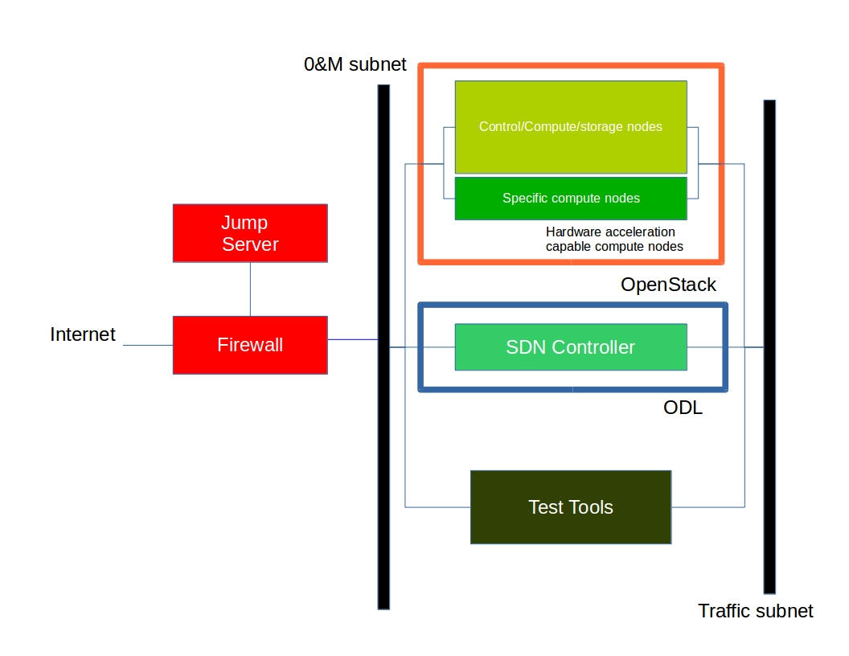

Pharos compliant environment
[hardwarespec:pharos-compliant-environment][hardwarespec::doc] A pharos compliant OPNFV test-bed provides:
- One CentOS 7 jump server on which the virtualized Openstack/OPNFV installer runs
- In the Brahmaputra release you may select a variety of deployment toolchains to deploy from the jump server.
- 5 compute / controller nodes (BGS requires 5 nodes)
- A configured network topology allowing for LOM, Admin, Public, Private, and Storage Networks
- Remote access as defined by the Jenkins slave configuration guide
http://artifacts.opnfv.org/brahmaputra.1.0/docs/opnfv-jenkins-slave-connection.brahmaputra.1.0.html

Hardware requirements
[hardwarespec:hardware-requirements] Servers
CPU:
- Intel Xeon E5-2600v2 Series
(Ivy Bridge and newer, or similar)
Local Storage Configuration:
Below describes the minimum for the Pharos spec, which is designed to provide enough capacity for a reasonably functional environment. Additional and/or faster disks are nice to have and may produce a better result.
- Disks: 2 x 1TB + 1 x 100GB SSD
- The first 1TB HDD should be used for OS & additional software/tool installation
- The second 1TB HDD configured for CEPH object storage
- Finally, the 100GB SSD should be used as the CEPH journal
- Performance testing requires a mix of compute nodes that have CEPH(swift+Cinder) and without CEPH storage
- Virtual ISO boot capabilities or a separate PXE boot server (DHCP/tftp or Cobbler)
Memory:
- 32G RAM Minimum
Power Supply Single
- Single power supply acceptable (redundant power not required/nice to have)

Networking
[networkconfig:networking][networkconfig::doc] Test-bed network
- 24 or 48 Port TOR Switch
- NICS - 1GE, 10GE - per server can be on-board or PCI-e
- Connectivity for each data/control network is through a separate NIC. *This simplifies Switch Management howeverrequires more NICs on the server and also more switch ports
- Lights-out network can share with Admin/Management
Network Interfaces
- Option I: 4x1G Control, 2x40G Data, 48 Port Switch
  - 1 x 1G for ILMI (Lights out Management )
  - 1 x 1G for Admin/PXE boot
  - 1 x 1G for control Plane connectivity
  - 1 x 1G for storage
  - 2 x 40G (or 10G) for data network (redundancy, NIC bonding, High bandwidth testing)
- Option II: 1x1G Control, 2x 40G (or 10G) Data, 24 Port Switch
  - Connectivity to networks is through VLANs on the Control NIC. * Data NIC used for VNF traffic and storage traffic segmented through VLANs
- Option III: 2x1G Control, 2x10G Data, 2x40G Storage, 24 Port Switch
  - Data NIC used for VNF traffic * Storage NIC used for control plane and Storage segmented through VLANs (separate host traffic from VNF)
  - 1 x 1G for IPMI
  - 1 x 1G for Admin/PXE boot
  - 2 x 10G for control plane connectivity/Storage
  - 2 x 40G (or 10G) for data network
Documented configuration to include: - Subnet, VLANs (may be constrained by existing lab setups or rules) - IPs - Types of NW - lights-out, public, private, admin, storage - May be special NW requirements for performance related projects - Default gateways
ontroller node bridge topology overview
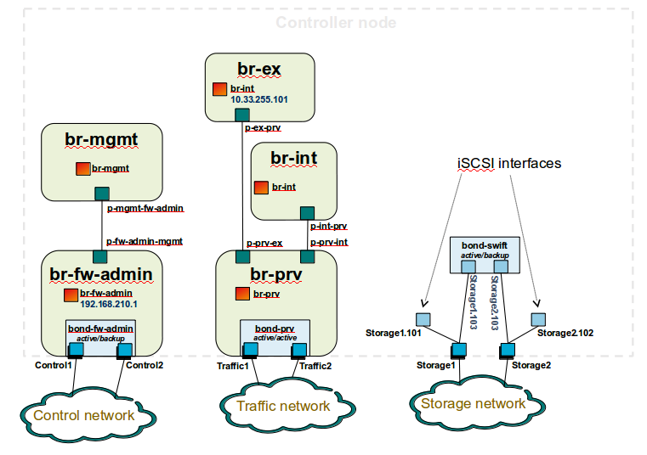
compute node bridge topology overview
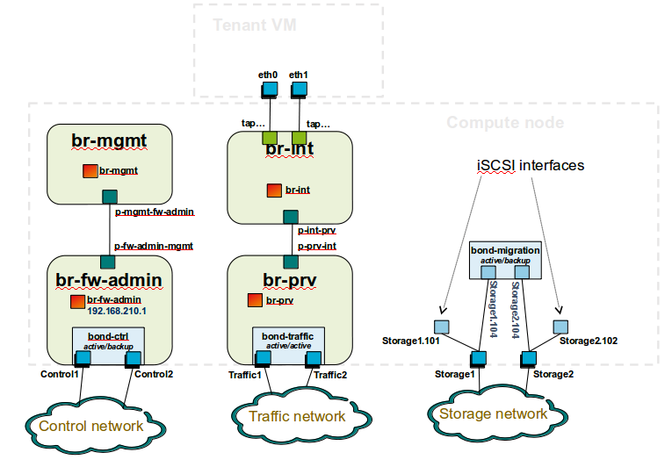

Architecture
[networkconfig:architecture] ** Network Diagram **
The Pharos architecture may be described as follow: Figure 1: Standard Deployment Environment
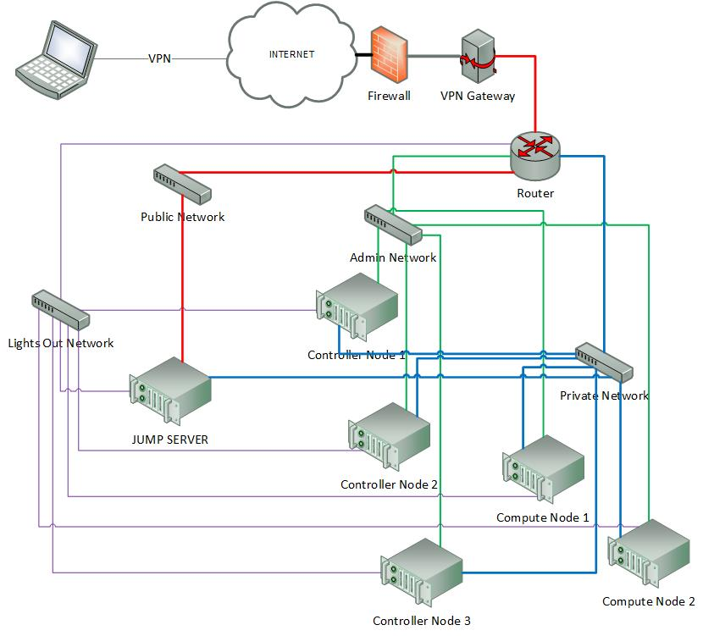
Figure 1: Standard Deployment Environment

Sample Network Drawings
[networkconfig:sample-network-drawings] Files for documenting lab network layout. These were contributed as Visio VSDX format compressed as a ZIP file. Here is a sample of what the visio looks like.
Download the visio zip file here: opnfv-example-lab-diagram.vsdx.zip
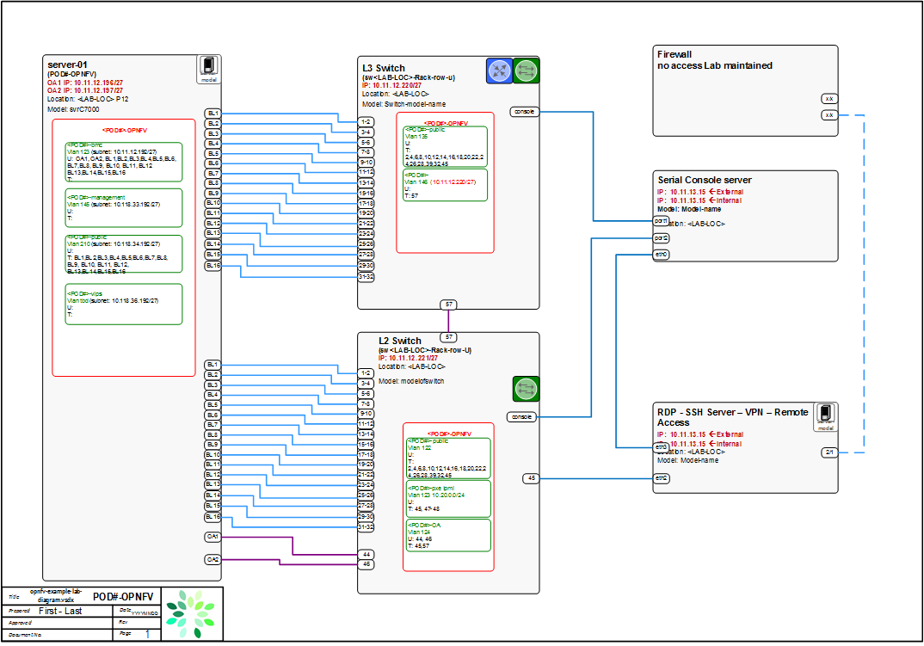

Jump Server Configuration
[jumpserverinstall:jump-server-configuration][jumpserverinstall::doc] Fuel
- Obtain CentOS 7 Minimal ISO and install

- Set parameters appropriate for your environment during installation
- Disable NetworkManager

- Configure your /etc/sysconfig/network-scripts/ifcfg-* files for your network
- Restart networking

- Edit /etc/resolv.conf and add a nameserver

- Install libvirt & kvm

- Reboot:

- If you wish to avoid annoying delay when use ssh to log in, disable DNS lookups:
Uncomment “UseDNS yes”, change ‘yes’ to ‘no’.
Save
- Restart sshd

- Install virt-install

- Visit artifacts.opnfv.org and D/L the OPNFV Fuel ISO
- Create a bridge using the interface on the PXE network, for example: br0
- Make a directory owned by qemu:

- Copy the ISO to /home/qemu

- Temporarily flush the firewall rules to make things easier:

- Connect to the console of the installing VM with your favorite VNC client.
- Change the IP settings to match the pod, use an IP in the PXE/Admin network for the Fuel Master

Remote management
[remoteaccess::doc][remoteaccess:remote-management] Remote access
- Remote access is required for …
  - Developers to access deploy/test environments (credentials to be issued per POD / user)
  - Connection of each environment to Jenkins master hosted by Linux Foundation for automated deployment and test
- OpenVPN is generally used for remote however community hosted labs may vary due to company security rules
- POD access rules / restrictions …
  - Refer to individual test-bed as each company may have different access rules and acceptable usage policies
- Basic requirement is for SSH sessions to be established (initially on jump server)
- Majority of packages installed on a system (tools or applications) will be pulled from an external repo.
Firewall rules should include
- SSH sessions
- Jenkins sessions
Lights-out Management:
- Out-of-band management for power on/off/reset and bare-metal provisioning
- Access to server is through lights-out-management tool and/or a serial console
- Intel lights-out ⇒ RMM http://www.intel.com/content/www/us/en/server-management/intel-remote-management-module.html
- HP lights-out ⇒ ILO http://www8.hp.com/us/en/products/servers/ilo/index.html
- CISCO lights-out ⇒ UCS https://developer.cisco.com/site/ucs-dev-center/index.gsp
Linux Foundation - VPN service for accessing Lights-Out Management (LOM) infrastructure for the UCS-M hardware
- People with admin access to LF infrastructure:
- amaged@cisco.com
- cogibbs@cisco.com
- daniel.smith@ericsson.com
- dradez@redhat.com
- fatih.degirmenci@ericsson.com
- fbrockne@cisco.com
- jonas.bjurel@ericsson.com
- jose.lausuch@ericsson.com
- joseph.gasparakis@intel.com
- morgan.richomme@orange.com
- pbandzi@cisco.com
- phladky@cisco.com
- stefan.k.berg@ericsson.com
- szilard.cserey@ericsson.com
- trozet@redhat.com
- The people who require VPN access must have a valid
PGP key bearing a valid signature from one of these three people. When issuing OpenVPN credentials, LF will be sending TLS certificates and 2-factor authentication tokens, encrypted to each recipient’s PGP key.
Authors
Trevor Cooper (Intel)
Version
1.0

Indices and tables
[index:indices-and-tables]

