PHAROS
OPNFV
July 19, 2016
[index::doc]

OPNFV Community Lab Infrastructure
[index:pharos][index:opnfv-community-lab-infrastructure][index:pharos-master]

Pharos Project Information
[information/pharos:pharos-information][information/pharos:pharos-project-information][information/pharos::doc]

Introduction
[information/pharos:introduction] The Pharos Project deals with developing an OPNFV lab infrastructure that is geographically and technically diverse. This will greatly assist in developing a highly robust and stable OPNFV platform. Community labs are hosted by individual companies and there is also an OPNFV lab hosted by the Linux Foundation that has controlled access for key development and production activities. The Pharos Specification defines a “compliant” deployment and test environment. Pharos is responsible for defining lab capabilities, developing management/usage policies and process; and a support plan for reliable access to project and release resources. Community labs are provided as a service by companies and are not controlled by Pharos however our goal is to provide easy visibility of all lab capabilities and their usage at all-times.
A requirement of Pharos labs is to provide bare-metal for development, deployment and testing. This is resource intensive from a hardware and support perspective while providing remote access can also be very challenging due to corporate IT policies. Achieving a consistent look and feel of a federated lab infrastructure continues to be an objective. Virtual environments are also useful and provided by some labs. Jira is currently used for tracking lab operational issues as well as for Pharos project activities.
Future lab capabilities are currently focussed on 1) Deployment automation 2) Dashboards (for capability and usage) 3) Virtual Labs for developer on-boarding.
- Pharos page: https://www.opnfv.org/developers/pharos
- Pharos project Wiki: https://wiki.opnfv.org/pharos
- Pharos Planning

Project Communication
[information/pharos:project-communication]
- Jira
- Weekly Pharos meeting
- Weekly coordination meeting for Test related projects
- IRC: freenode.net #opnfv-pharos http://webchat.freenode.net/?channels=opnfv-pharos
- Mailing List: use opnfv-tech-discuss and tag your emails with [Pharos] in the subject for filtering

Project Release Artifacts
[information/pharos:project-release-artifacts]
- Project Repository: https://gerrit.opnfv.org/gerrit/#/q/pharos
- Continuous Integration https://build.opnfv.org/ci/view/pharos/
- Documentation: http://artifacts.opnfv.org/pharos/docs/

Pharos Lab Process
[information/pharos:pharos-lab-process]
- Process for requesting lab access and support https://wiki.opnfv.org/pharos_rls_b_support
- Pharos Lab Governance and Policies https://wiki.opnfv.org/pharos_policies
- Status of Community labs https://wiki.opnfv.org/pharos_rls_b_labs

Current Labs
[information/pharos:current-labs] An interactive map of OPNFV lab locations, lab owners and other lab information is maintained on the Pharos Wiki
|p0.237|p0.237|p0.237|p0.237|
# & Hosted by & Home page & Location
1 &
Linux
Foundation
& https://wiki.opnfv.org/get_started/lflab_hosting & Portland, Oregon
2 & Spirent & https://wiki.opnfv.org/pharos/spirentvctlab & Nephoscale, CA
3 & China Mobile & https://wiki.opnfv.org/lab2_chinamobile_hosting & Beijing, China
4 & Dell & https://wiki.opnfv.org/dell_hosting & Santa Clara, CA
5 & Enea & https://wiki.opnfv.org/enea-pharos-lab & Kista, Sweden
6 & Ericsson & https://wiki.opnfv.org/get_started/ericsson_hosting & Montreal, Canada
7 & Huawei & https://wiki.opnfv.org/lab4_huawei & Xi an, China
8 & Huawei & https://wiki.opnfv.org/get_started/huawei_sc_hosting & Santa Clara, CA
9 & Intel & https://wiki.opnfv.org/get_started/intel_hosting & Hillsboro, Oregon
10 & Orange & https://wiki.opnfv.org/opnfv-orange & Lannion, France
11 & Orange & https://wiki.opnfv.org/opnfv-orange & Paris, France
12 & ZTE & https://wiki.opnfv.org/zte-nj-testlab & Nan Jing, China
13 &
Okinawa
Open Lab
& https://wiki.opnfv.org/display/pharos/OOL+TestLab & Okinawa

Pharos project Key Facts
[information/pharos:pharos-project-key-facts] Key Project Facts are maintained in the Pharos INFO file in the project repo
- Can be viewed on the project Wiki INFO
- Project key facts in repo: pharos/INFO

Pharos Specification
[specification/pharosspec:pharos-specification][specification/pharosspec::doc] The Pharos Specification provides information on Pharos hardware and network requirements

Pharos Compliance
[specification/objectives:pharos-compliance][specification/objectives::doc] The Pharos Specification defines a hardware environment for deployment and testing of the Brahmaputra platform release. The Pharos Project is also responsible for defining lab capabilities, developing management/usage policies and process; and a support plan for reliable access to project and release resources. Community labs are provided as a service by companies and are not controlled by Pharos however our objective is to provide easy visibility of all lab capabilities and their usage at all-times.
Pharos lab infrastructure has the following objectives: - Provides secure, scalable, standard and HA environments for feature development - Supports the full Brahmaputra deployment lifecycle (this requires a bare-metal environment) - Supports functional and performance testing of the Brahmaputra release - Provides mechanisms and procedures for secure remote access to Pharos compliant environments for OPNFV community
Deploying Brahmaputra in a Virtualized environment is possible and will be useful, however it does not provide a fully featured deployment and realistic test environment for the Brahmaputra release of OPNFV.
The high level architecture is outlined in the following diagram:
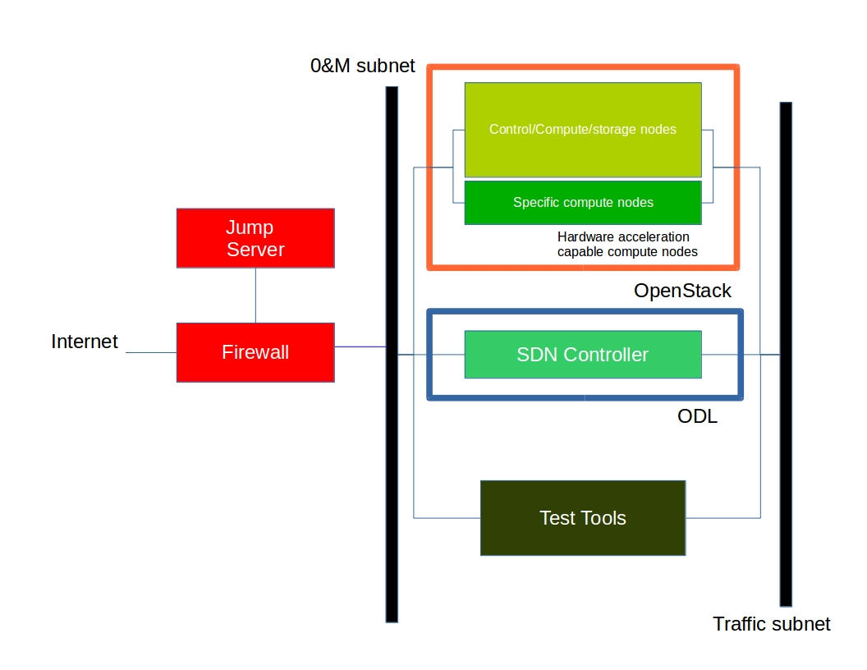

Hardware
[specification/hardwarespec:hardware][specification/hardwarespec::doc] A pharos compliant OPNFV test-bed provides:
- One CentOS 7 jump server on which the virtualized Openstack/OPNFV installer runs
- In the Brahmaputra release you may select a variety of deployment toolchains to deploy from the jump server.
- 5 compute / controller nodes (BGS requires 5 nodes)
- A configured network topology allowing for LOM, Admin, Public, Private, and Storage Networks
- Remote access as defined by the Jenkins slave configuration guide
http://artifacts.opnfv.org/brahmaputra.1.0/docs/opnfv-jenkins-slave-connection.brahmaputra.1.0.html
Servers
CPU:
- Intel Xeon E5-2600v2 Series or newer
Local Storage:
Below describes the minimum for the Pharos spec, which is designed to provide enough capacity for a reasonably functional environment. Additional and/or faster disks are nice to have and mayproduce a better result.
- Disks: 2 x 1TB HDD + 1 x 100GB SSD (or greater capacity)
- The first HDD should be used for OS & additional software/tool installation
- The second HDD is configured for CEPH object storage
- The SSD should be used as the CEPH journal
- Performance testing requires a mix of compute nodes with CEPH (Swift+Cinder) and without CEPH storage
- Virtual ISO boot capabilities or a separate PXE boot server (DHCP/tftp or Cobbler)
Memory:
- 32G RAM Minimum
Power Supply
- Single power supply acceptable (redundant power not required/nice to have)

Networking
[specification/networkconfig:networking][specification/networkconfig::doc] Network Hardware
- 24 or 48 Port TOR Switch
- NICs - Combination of 1GE and 10GE based on network topology options (per server can be on-board or use PCI-e)
- Connectivity for each data/control network is through a separate NIC. This simplifies Switch Management however requires more NICs on the server and also more switch ports
- BMC (Baseboard Management Controller) for lights-out mangement network using IPMI (Intelligent Platform Management Interface)
Network Options
- Option I: 4x1G Control, 2x10G Data, 48 Port Switch
  - 1 x 1G for lights-out Management
  - 1 x 1G for Admin/PXE boot
  - 1 x 1G for control-plane connectivity
  - 1 x 1G for storage
  - 2 x 10G for data network (redundancy, NIC bonding, High bandwidth testing)
- Option II: 1x1G Control, 2x 10G Data, 24 Port Switch
  - Connectivity to networks is through VLANs on the Control NIC
  - Data NIC used for VNF traffic and storage traffic segmented through VLANs
- Option III: 2x1G Control, 2x10G Data, 2x10G Storage, 24 Port Switch
  - Data NIC used for VNF traffic
  - Storage NIC used for control plane and Storage segmented through VLANs (separate host traffic from VNF)
  - 1 x 1G for lights-out mangement
  - 1 x 1G for Admin/PXE boot
  - 2 x 10G for control-plane connectivity/storage
  - 2 x 10G for data network
Documented configuration to include:
- Subnet, VLANs (may be constrained by existing lab setups or rules)
- IPs
- Types of NW - lights-out, public, private, admin, storage
- May be special NW requirements for performance related projects
- Default gateways
Sample Network Drawings
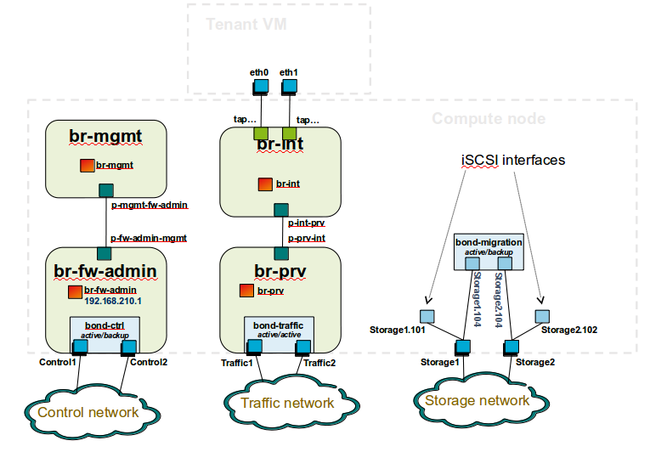
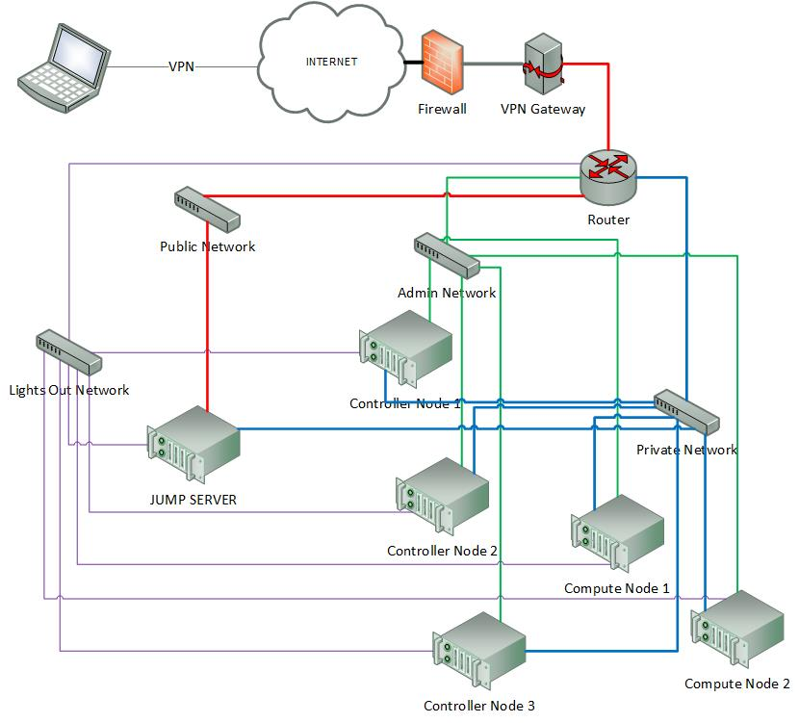
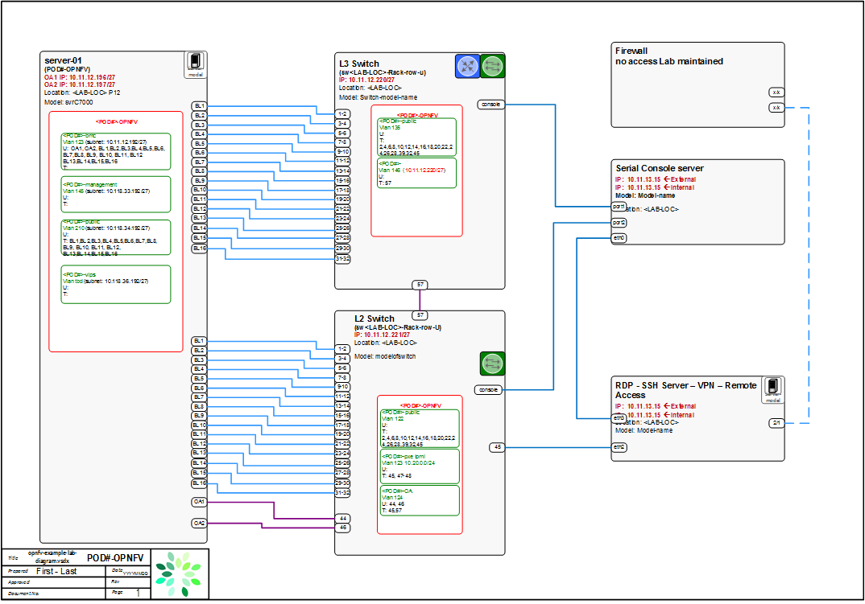
Download the visio zip file here: opnfv-example-lab-diagram.vsdx.zip

Remote Management
[specification/remoteaccess::doc][specification/remoteaccess:remote-management] Remote access is required for …
- Developers to access deploy/test environments (credentials to be issued per POD / user)
- Connection of each environment to Jenkins master hosted by Linux Foundation for automated deployment and test
OpenVPN is generally used for remote however community hosted labs may vary due to company security rules. For POD access rules / restrictions refer to individual lab documentation as each company may have different access rules and acceptable usage policies.
Basic requirements:
- SSH sessions to be established (initially on the jump server)
- Packages to be installed on a system (tools or applications) by pullig from an external repo.
Firewall rules accomodate:
- SSH sessions
- Jenkins sessions
Lights-out management network requirements:
- Out-of-band management for power on/off/reset and bare-metal provisioning
- Access to server is through a lights-out-management tool and/or a serial console
- Refer to applicable light-out mangement information from server manufacturer, such as ...
  - Intel lights-out RMM
  - HP lights-out ILO
  - CISCO lights-out UCS
Linux Foundation Lab is a UCS-M hardware environment with controlled access as needed
- Access rules and procedure are maintained on the Wiki
- A list of people with access is maintained on the Wiki
- Send access requests to infra-steering@lists.opnfv.org with the following information ...
  - Name:
  - Company:
  - Approved Project:
  - Project role:
  - Why is access needed:
  - How long is access needed (either a specified time period or define “done”):
  - What specific POD/machines will be accessed:
  - What support is needed from LF admins and LF community support team:
- Once access is approved please follow instructions for setting up VPN access ... https://wiki.opnfv.org/get_started/lflab_hosting
- The people who require VPN access must have a valid PGP key bearing a valid signature from LF
- When issuing OpenVPN credentials, LF will be sending TLS certificates and 2-factor authentication tokens, encrypted to each recipient’s PGP key

Pharos Templates and Configuration Files
[lab-description/templates:pharos-templates-and-configuration-files][lab-description/templates::doc] Lab and POD templates are provided to help lab owners document capabilities, configurations and network topologies. Compute, network and storage specifications with network topology details are required to help developers use lab resources efficiently while minimizing support needs. This also greatly assists with troubleshhoting. It is the responsibility of the lab owner to keep individual lab documents updated and determine appropriate level of detail that is exposed publically through the Wiki or maintained in a secure Pharos repo with controlled access.
While human readable configuration files are needed, the goal is for full automation of deployments. This requires a common machine readable format for POD configurations as input to every installer. This is the “POD inventory” common format file.

Lab Specification Template
[lab-description/lab_{d}escription:lab-specification-template][lab-description/lab_{d}escription::doc][lab-description/lab_{d}escription:pharos-lab]

Introduction
[lab-description/lab_{d}escription:introduction] Add an summary of what your lab hosts, its focus areas and purpose

Lab Resources
[lab-description/lab_{d}escription:lab-resources]
|L|L|L|L|L|L|L|
POD Name & Project(s) & Project Lead(s) & Email(s) & POD Role & Status & Notes
POD1 & project name & John Doe & john@abc.com & CI: stable & Active &
- POD Name: Use consistent naming / numbering to avoid confusion. Hyperlinked to POD description.
- POD Role: CI stable, CI latest, Dev/test, Stand-alone, Virtual, ...
- Status: Assigned, Configuring, Active, Troubleshooting, Available, ...

Acceptable Usage Policy
[lab-description/lab_{d}escription:acceptable-usage-policy] Define lab user policies and expectations

Remote Access Infrastructure
[lab-description/lab_{d}escription:remote-access-infrastructure] Describe lab remote access setup (typically VPN, also link speed, any known restrictions, etc.)

Remote Access Procedure
[lab-description/lab_{d}escription:remote-access-procedure] Define lab process for requesting access to the lab (e.g. VPN guide, how to modify BIOS settings, etc.)

Lab Documentation
[lab-description/lab_{d}escription:lab-documentation] List lab specific documents here

Lab Topology
[lab-description/lab_{d}escription:lab-topology] Provide a diagram showing the network topology of lab including lights-out network. Any security sensitive details should not be exposed publically. The following diagram is an example only.
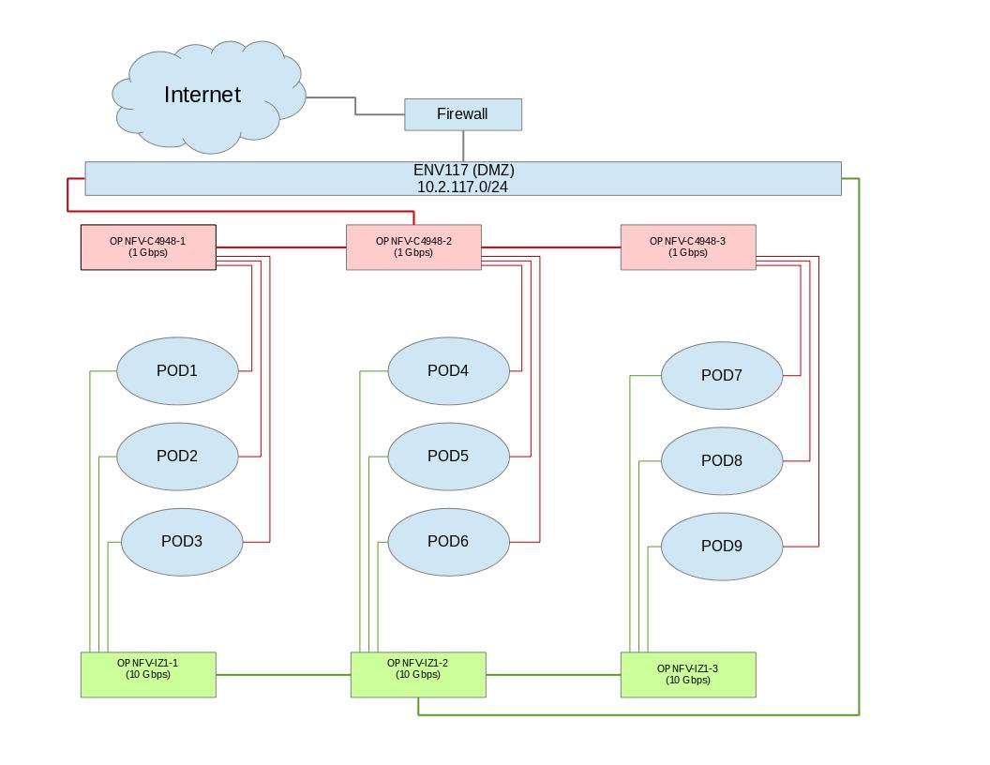

POD Specification Template
[lab-description/pod_{d}escription:pharos-pod][lab-description/pod_{d}escription::doc][lab-description/pod_{d}escription:pod-specification-template]

Introduction
[lab-description/pod_{d}escription:introduction] Add an summary of the POD usage (Project, CI stable, CI latest, dev/test, stand-alone servers, etc.)

Additional Requirements
[lab-description/pod_{d}escription:additional-requirements] Describe any addional POD requirements beyond a standard Pharos compliant POD e.g. test equipment, shared usage, ...

Server Specifications
[lab-description/pod_{d}escription:server-specifications] Jump Host
|L|L|L|L|L|L|L|L|L|L|L|
Hostname & Vendor & Model & Serial Number & CPUs & Memory & Local storage & Lights-out network (IPMI): IP/MAC, U/P & 1GbE: NIC#/IP MAC/VLAN/Network & 10GbE: NIC#/IP MAC/VLAN/Network & Notes
pod2-jp-jump & Dell & R730 & ABCDEF007 & 2 x E5-2699 & 64 GB & 240GB SSD 1 TB SATA & 10.10.10.10 00:1E:67:D4:36:9A root/root & IF0: 10.2.117.36 00:1E:67:4F:B7:B1 VLAN 984 Public IF1: 10.2.1.1 00:1E:67:4F:B7:B2 VLAN 201 Admin & IF2: 10.2.12.1 00:1E:67:4F:B7:B4 VLAN 202 Private IF3: 10.2.13.1 00:1E:67:4F:B7:B5 VLAN 203 Storage &
Compute Nodes
|L|L|L|L|L|L|L|L|L|L|L|
Hostname & Vendor & Model & Serial Number & CPUs & Memory & Local storage & Lights-out network (IPMI): IP/MAC, U/P & 1GbE: NIC#/IP MAC/VLAN/Network & 10GbE: NIC#/IP MAC/VLAN/Network & Notes
pod2-jp-node1 & & & & & & & & & &
pod2-jp-node2 & & & & & & & & & &
pod2-jp-node3 & & & & & & & & & &
pod2-jp-node4 & & & & & & & & & &
pod2-jp-node5 & & & & & & & & & &

VPN Users
[lab-description/pod_{d}escription:vpn-users]
|L|L|L|L|L|
Name & Email & Project & Role & Notes
joe user & ju@gmail.com & Pharos & contributer & CI support

Firewall Rules
[lab-description/pod_{d}escription:firewall-rules]
|L|L|L|
Port(s) & Service & Note
22, 43, 80 & Jenkins CI &

POD Topology
[lab-description/pod_{d}escription:pod-topology] Provide a diagram showing the network topology of the POD. Any security sensitive details should not be exposed publically and can be stored in the secure Pharos repo. The following diagram is an example only.
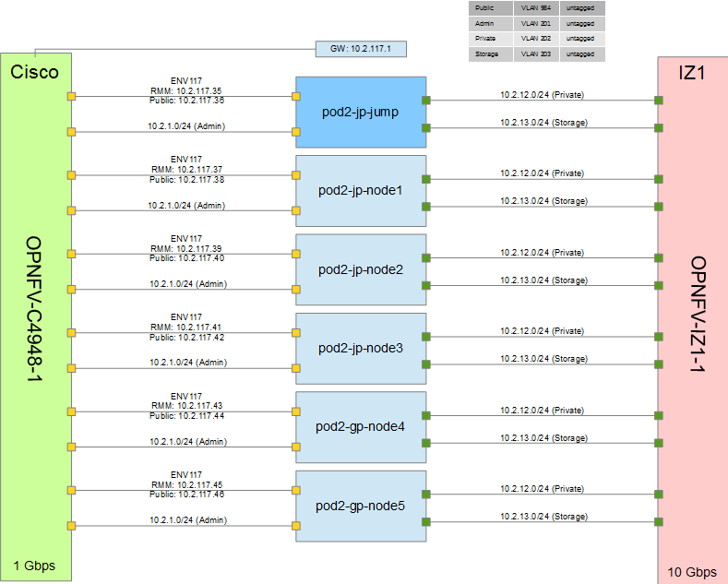

POD Inventory File
[lab-description/inventory::doc][lab-description/inventory:pod-inventory-file] The Common Inventory File provides a template for machine reabable input into every installer. For convenience the YAML file template currently resides in the Genesis Project repo. Refer to the following patch for further infomation https://gerrit.opnfv.org/gerrit/#/c/4079.

Pharos Configuration
[configguide/pharosconfig:pharos-configuration][configguide/pharosconfig::doc] OPNFV development, test and production activities rely on Pharos resources and support from the Pharos community. Lab owners and Pharos project committers/contributors will evolve the vision for Pharos as well as expand lab capabilities that are needed to help OPNFV be highly successful.
Pharos configuration documents provide information on how to setup hardware and networks in a Pharos compliant lab. Jira is used to track Pharos activities including lab operations. PODs are connected to Jenkins and generally available 24/7 other than scheduled maintenance and troubleshooting. Lab resources are declared as either for Development (bare-metal or virtual), Production latest (bare-metal) or Production stable (bare-metal)

Lab Setup Guide
[configguide/configguide:lab-setup-guide][configguide/configguide::doc] Provides an overview for setting up a Pharos lab. A full set of documents are maintained in the pharos repo.
When setting up an OPNFV community lab ...
- Provide the Pharos community with details of the intended setup, including ...
  - Overview of resources are being offered to the community, intended purpose and known limitations
  - Lab owner name with contacts
  - Timelines for availablity for development, test, release production, ...
- Update the Pharos Wiki with lab details
  - Lab map, organization, contacts, status, location, resources, role, etc.
  - https://wiki.opnfv.org/pharos#community_labs
- Update the Pharos project information file “Current Labs”
- Create new Wiki pages for lab and POD specific information
  - Access procedures
  - Usage guidelines for developers
  - Update infomtation as PODs are re-assigned or usage/availability changes
- Fill Lab and POD templates ... ...
  - Note that security sensitive lab information should be stored in the secure Pharos repo
- Connect PODs to Jenkins/CI

Updating Pharos Documents
[configguide/lab_{u}pdate_{g}uide:updating-pharos-documents][configguide/lab_{u}pdate_{g}uide::doc][configguide/lab_{u}pdate_{g}uide:pharos-wiki] Details about each Community Lab is found in 3 places:
- Summary of lab including location, contacts, status, etc. on the Pharos Project Wiki page
- Lab specific details are provided with dedicated Wiki pages, see this Example Lab
- Pharos repo docs ...
  - docs/information/pharos.rst ... project information file
  - docs/labs/ ... Lab documents (includes lab specific capabilities, usages and policies; POD information)
  - docs/labs/images/ ... Lab and POD toplogies

Update Pharos repo
[configguide/lab_{u}pdate_{g}uide:update-pharos-repo] Clone the Pharos Git repository
- Make the changes to Pharos project information file (docs/information/pharos.rst)
- After code gets merged http://artifacts.opnfv.org/pharos/docs/information/pharos.html will contain your change

Update Pharos Wiki
[configguide/lab_{u}pdate_{g}uide:update-pharos-wiki] Edit Wiki page
- https://wiki.opnfv.org/pharos
- Look for {{scrape>http://artifacts.opnfv.org/pharos/docs/information/pharos.html}}
- Click “Preview” and see if your change is shown; if shown add a short “Edit summary” and click “Save” (Wiki does not auto update content)
You will see a section of code as shown below. Add your page to the bullet list with wiki link, nice name, and location summary
Update the map info on the Pharos Project Page https://wiki.opnfv.org/pharos?&#community_labs
- You will see a section of code as shown below. Add your lab infomation to the list with a comma separated list as follows:
  - longitude
  - latitude
  - .8 <- for size
  - marker color png ([[marker-green.pngmarker-green.png]], [[marker-blue.pngmarker-blue.png]], [[marker-red.pngmarker-red.png]], [[marker-gold.pngmarker-gold.png]])
  - Nice Format Lab Name
  - ‘’;’`
  - Location Summary
  - ‘’\’’ <– for a new line
  - external link: <– optional
MAP:
\PYGZlt{}olmap id=\PYGZdq{}olMapOne\PYGZdq{} width=\PYGZdq{}877px\PYGZdq{} height=\PYGZdq{}200px\PYGZdq{} lat=\PYGZdq{}45.0\PYGZdq{} lon=\PYGZdq{}0.0\PYGZdq{} zoom=\PYGZdq{}3\PYGZdq{} statusbar=\PYGZdq{}1\PYGZdq{} toolbar=\PYGZdq{}1\PYGZdq{} controls=\PYGZdq{}1\PYGZdq{}
poihoverstyle=\PYGZdq{}0\PYGZdq{} baselyr=\PYGZdq{}OpenStreetMap\PYGZdq{} gpxfile=\PYGZdq{}\PYGZdq{} kmlfile=\PYGZdq{}\PYGZdq{}\PYGZgt{}
45.52,\PYGZhy{}122.67,60,.8,marker\PYGZhy{}red.png,Linux Foundation;Portland, Oregon \PYGZbs{}\PYGZbs{} external link: [[http://www.test.com\textbar{}test.com]]
39.7392,\PYGZhy{}104.9902,60,.8,marker\PYGZhy{}red.png,Cable Labs;Denver, CA \PYGZbs{}\PYGZbs{} external link: [[http://www.test.com\textbar{}test.com]]
37.333685,\PYGZhy{}121.891272,60,.6,marker\PYGZhy{}green.png,[[pharos/spirentvctlab\textbar{}Spirent VCT Lab]] \PYGZbs{}\PYGZbs{} San Jose, California
39.90,116.35,60,.8,marker\PYGZhy{}red.png,China Mobile Labs;Beijing, China \PYGZbs{}\PYGZbs{} external link: [[http://www.test.com\textbar{}test.com]]
37.413137,\PYGZhy{}121.977975,\PYGZhy{}180,.6,marker\PYGZhy{}red.png,Dell Labs;Santa Clara, California \PYGZbs{}\PYGZbs{} link: [[https://wiki.opnfv.org/dell\PYGZus{}hosting]]
59.41,17.95,60,.8,marker\PYGZhy{}red.png,Enea Pharos Lab;Kista, Sweden \PYGZbs{}\PYGZbs{} external link: [[http://www.enea.com/pharos\PYGZhy{}lab\textbar{}ENEA pharos lab]]
45.50,\PYGZhy{}73.66,60,.8,marker\PYGZhy{}blue.png,Ericsson Labs;Montreal, Canada \PYGZbs{}\PYGZbs{} external link: [[http://www.test.com\textbar{}test.com]]
34.26,108.97,60,.8,marker\PYGZhy{}green.png, Huawei Labs;Xi an, China \PYGZbs{}\PYGZbs{} external link: [[http://www.test.com\textbar{}test.com]]
37.373424,\PYGZhy{}121.964913,60,.8,marker\PYGZhy{}green.png, Huawei Labs;Santa Clara, USA \PYGZbs{}\PYGZbs{} external link: [[http://www.test.com\textbar{}test.com]]
45.53,\PYGZhy{}122.97,60,.8,marker\PYGZhy{}green.png,Intel Labs;Hillsboro, Oregon \PYGZbs{}\PYGZbs{} link: [[https://wiki.opnfv.org/get\PYGZus{}started/intel\PYGZus{}hosting\textbar{}intel\PYGZus{}hosting]]
48.75867,\PYGZhy{}3.45196,60,.8,marker\PYGZhy{}gold.png,Orange Labs;Lannion, France \PYGZbs{}\PYGZbs{} external link: [[http://www.test.com\textbar{}test.com]]
48.825786,2.274797,\PYGZhy{}60,.8,marker\PYGZhy{}gold.png,Orange Labs;Paris, France \PYGZbs{}\PYGZbs{} external link: [[http://www.test.com\textbar{}test.com]]
31.97,118.79,60,.8,marker\PYGZhy{}red.png,ZTE Labs;Nan Jing, China \PYGZbs{}\PYGZbs{} link:[[zte\PYGZhy{}nj\PYGZhy{}testlab\textbar{}ZTE, Nan Jing]]
[[http://test.com\textbar{}test.com]] \PYGZbs{}\PYGZbs{} internal link: [[::start]]\PYGZbs{}\PYGZbs{} **DW Formatting**
\PYGZlt{}/olmap\PYGZgt{}

Jump Server Configuration
[configguide/jumpserverinstall:jump-server-configuration][configguide/jumpserverinstall::doc] Jump server install procedures are maintained by each installer project. Addional Jump server configuraton BKMs will be maintained here. The below install information was used for Fuel however may be outdated (please refer to Fuel Installer documents).
Procedure
- Obtain CentOS 7 Minimal ISO and install

- Set parameters appropriate for your environment during installation
- Disable NetworkManager

- Configure your /etc/sysconfig/network-scripts/ifcfg-* files for your network
- Restart networking

- Edit /etc/resolv.conf and add a nameserver, for example 8.8.8.8

- Install libvirt & kvm

- Reboot:

- Configure SSHD
If you wish to avoid annoying delay when use ssh to log in, disable DNS lookups:
When UseDNS is existed in the config file, update it:
or append the setting when not existed:
Disable Password Authenticaion for security:
If you want to disable IPv6 connections, comment IPv6 ListenAddress and change AddressFamily to inet:

- Restart sshd

- Install virt-install

- Visit artifacts.opnfv.org and D/L the OPNFV Fuel ISO
- Create a bridge using the interface on the PXE network, for example: br0

- Make a directory owned by qemu:

- Copy the ISO to /home/qemu

- Temporarily flush the firewall rules to make things easier:

- Connect to the console of the installing VM with your favorite VNC client.
- Change the IP settings to match the pod, use an IP in the PXE/Admin network for the Fuel Master

Indices
[index:indices]

