OOL OPNFV Testbed
OPNFV
August 23, 2016
[index::doc]

Lab: OOL OPNFV Testbed
[lab_{d}escription:ool-opnfv-testbed][lab_{d}escription::doc][lab_{d}escription:lab-ool-opnfv-testbed]

Introduction
[lab_{d}escription:introduction] Okinawa Open Laboratory (OOL) provides the following facilities for OPNFV testing. The testlab is now located only at Okinwa in Japan.

Lab Resources
[lab_{d}escription:lab-resources][lab_{d}escription:okinawa-open-laboratory-ool]
|L|L|L|L|L|L|L|
POD Name & Project(s) & Project Lead(s) & Email(s) & POD Role & Status & Notes
ool-pod1 & & & & CI stable & Available &
ool-virtual1 & Doctor & Ryota Mibu & r-mibu@cq.jp.nec.com & CI review & Assigned &

Acceptable Usage Policy
[lab_{d}escription:ool-pod1][lab_{d}escription:acceptable-usage-policy] These resources provided to OPNFV are free to use by any OPNFV contributor or committer for the purpose of OPNFV approved activities by permission of the operator, but shall be used for CI, infra setup/configuration and troubleshooting purposes.

Remote Access Infrastructure
[lab_{d}escription:remote-access-infrastructure] OOL provide VPN(OpenVPN) to connect this testlab.

Remote Access Procedure
[lab_{d}escription:remote-access-procedure] Access to this environment can be granted by sending a e-mail to: TBD
subject: opnfv_access_ool
Following information should be provided in the request:
- Full name
- e-mail
- Phone
- Organization
- Resources required
- How long is access needed
- PGP public key
- SSH public key
Granting access normally takes 2-3 business days.
Detailed access descriptions will be provided with your access grant e-mail.

Lab Documentation
[lab_{d}escription:lab-documentation]

Lab Topology
[lab_{d}escription:lab-topology] 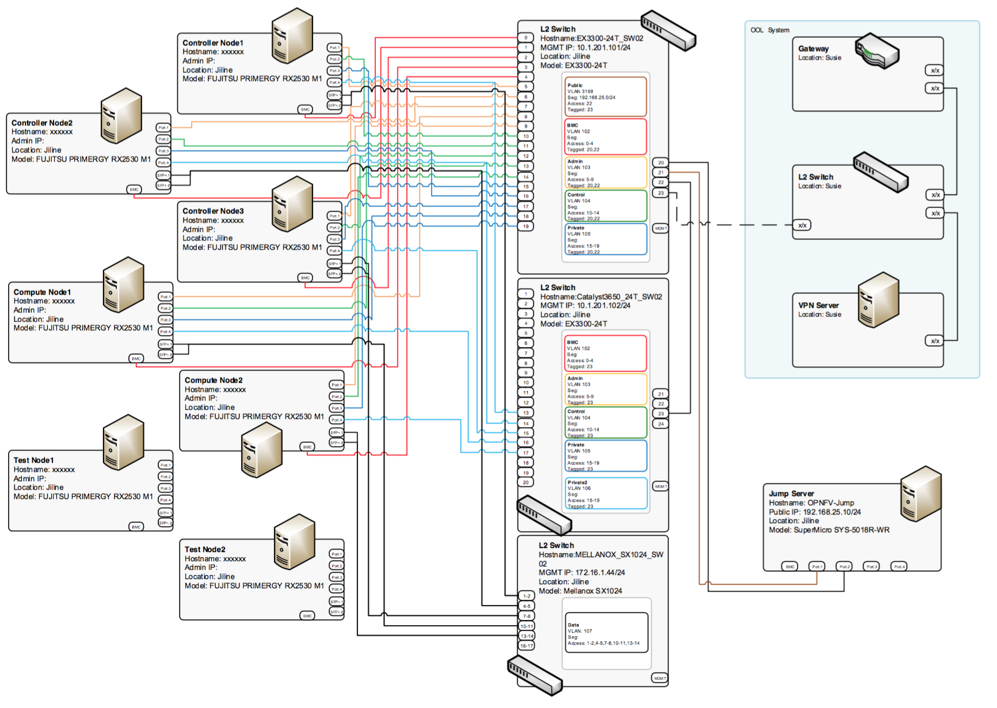

POD: ool-pod1
[pod1_{d}escription::doc][pod1_{d}escription:pod-ool-pod1]

Introduction
[pod1_{d}escription:introduction] This is a physical POD deployed by Fuel installer (Brahmputra).

Additional Requirements
[pod1_{d}escription:additional-requirements]

Server Specifications
[pod1_{d}escription:ool-pod1-spec][pod1_{d}escription:server-specifications] Jump Host
|p0.136|p0.136|p0.136|p0.136|p0.136|p0.136|p0.136|
& & & & & &
OPNFV-jump & SuperMicro & SYS-5018R-WR &
& E5-2630v3 x1 & 32 GB & SATA 7.2krpm 2TB x1
|p0.190|p0.190|p0.190|p0.190|p0.190|
& & & &
OPNFV-jump &
& IF0: 0c:c4:7a:6c:a2:b2 VLAN untagged Public IF1: 0c:c4:7a:6c:a2:b3 VLAN 10{2-5} Admin/Mgmt/Private & & NIC Model: Intel I350
Compute Nodes
|p0.136|p0.136|p0.136|p0.136|p0.136|p0.136|p0.136|
& & & & & &
node-9 & FUJITSU & RX2530 M1 &
& E5-2630v3 x1 & 32 GB & SATA 7.2krpm 2TB x2 SSD 100GB x1
node-10 & FUJITSU & RX2530 M1 &
& E5-2630v3 x1 & 32 GB & SATA 7.2krpm 2TB x2 SSD 100GB x1
node-11 & FUJITSU & RX2530 M1 &
& E5-2630v3 x1 & 32 GB & SATA 7.2krpm 2TB x2 SSD 100GB x1
node-12 & FUJITSU & RX2530 M1 &
& E5-2630v3 x1 & 32 GB & SATA 7.2krpm 2TB x2 SSD 100GB x1
|p0.190|p0.190|p0.190|p0.190|p0.190|
& & & &
node-9 &
& IF0: 90:1b:0e:6b:e8:a8 VLAN untagged Admin IF1: 90:1b:0e:6b:e8:a9 VLAN untagged Mgmt IF2: 90:1b:0e:6b:e8:aa VLAN untagged Public IF3: 90:1b:0e:6b:e8:ab VLAN untagged Private & IF4: 90:1b:0e:6d:09:71 VLAN untagged Storage IF5: 90:1b:0e:6d:09:72 VLAN untagged Storage & NIC Models: (1GbE) Emulex Skyhawk (10GbE) Intel 82599E
node-10 &
& IF0: 90:1b:0e:6b:e3:00 VLAN untagged Admin IF1: 90:1b:0e:6b:e3:01 VLAN untagged Mgmt IF2: 90:1b:0e:6b:e3:02 VLAN untagged Public IF3: 90:1b:0e:6b:e3:03 VLAN untagged Private & IF4: 90:1b:0e:6d:09:5f VLAN untagged Storage IF5: 90:1b:0e:6d:09:60 VLAN untagged Storage & NIC Models: (1GbE) Emulex Skyhawk (10GbE) Intel 82599E
node-11 &
& IF0: 90:1b:0e:6b:e5:b4 VLAN untagged Admin IF1: 90:1b:0e:6b:e5:b5 VLAN untagged Mgmt IF2: 90:1b:0e:6b:e5:b6 VLAN untagged Public IF3: 90:1b:0e:6b:e5:b7 VLAN untagged Private & IF4: 90:1b:0e:6d:09:6f VLAN untagged Storage IF5: 90:1b:0e:6d:09:70 VLAN untagged Storage & NIC Models: (1GbE) Emulex Skyhawk (10GbE) Intel 82599E
node-12 &
& IF0: 90:1b:0e:6b:e2:bc VLAN untagged Admin IF1: 90:1b:0e:6b:e2:bd VLAN untagged Mgmt IF2: 90:1b:0e:6b:e2:be VLAN untagged Public IF3: 90:1b:0e:6b:e2:bf VLAN untagged Private & IF4: 90:1b:0e:6d:08:31 VLAN untagged Storage IF5: 90:1b:0e:6d:08:32 VLAN untagged Storage & NIC Models: (1GbE) Emulex Skyhawk (10GbE) Intel 82599E
Switches
|L|L|
&
Switch 1 (for each network except storage) & Juniper EX3300-24T
Switch 2 (for storage) & Mellanox SX1024
Subnet Allocations
|L|L|L|L|L|
& & & &
Public & 192.168.25.0 & 255.255.255.0 & 192.168.25.254 & 103
Fuel Admin & 192.168.103.0 & 255.255.255.0 & 192.168.103.1 & 103
Fuel Mangement & 192.168.104.0 & 255.255.255.0 & 192.168.104.1 & 104
Fuel Public & 192.168.105.0 & 255.255.255.0 & 192.168.105.1 & 105
Fuel Private & 192.168.106.0 & 255.255.255.0 & & Untagged
Fuel Storage & 192.168.107.0 & 255.255.255.0 & & Untagged

VPN Users
[pod1_{d}escription:vpn-users]
|L|L|L|L|L|
Name & Email & Project & Role & Notes
Ryota Mibu & r-mibu@cq.jp.nec.com & Doctor & Project Lead &

Firewall Rules
[pod1_{d}escription:firewall-rules]
|L|L|L|
Port(s) & Service & Notes
& &

POD Topology
[pod1_{d}escription:pod-topology]

POD: ool-virtual1
[virtual1_{d}escription::doc][virtual1_{d}escription:pod-ool-virtual1]

Introduction
[virtual1_{d}escription:introduction] This is a virtual POD deployed by Apex installer (master/Colorado). This POD is built on one machine placed next to machines of the physical POD (ool-pod1). Controller and compute nodes are VM.

Additional Requirements
[virtual1_{d}escription:additional-requirements]

Server Specifications
[virtual1_{d}escription:server-specifications] Jump Host
See .
Compute Nodes
|L|L|L|
& &
Virtual POD & ool-virtual1 & FUJITSU PRIMERGY RX2530 M1
|p0.317|p0.317|p0.317|
CPU & Xeon E5-2630v3 & x1
RAM & 32GB &
HDD & SATA 7.2krpm 2TB & x2
SSD & 100GB & x1
1000BASE-T & Emulex Skyhawk & x2
10GBASE-T & Intel 82599E & x2
BMC &
& x1
|L|L|L|L|L|L|
& & & & &
ool-virtual1 & IF0 & 1Gb & 90:1b:0e:6b:e5:d8 & eno1 & Admin
ool-virtual1 & IF1 & 1Gb & 90:1b:0e:6b:e5:d9 & eno2 & Mgmt
ool-virtual1 & IF2 & 1Gb & 90:1b:0e:6b:e5:da & eno3 & Public
ool-virtual1 & IF3 & 1Gb & 90:1b:0e:6b:e5:db & eno4 & Private
ool-virtual1 & IF4 & 1Gb & 90:1b:0e:6d:08:f5 & ens2f0 & Storage
ool-virtual1 & IF5 & 1Gb & 90:1b:0e:6d:08:f6 & ens2f1 & Storage
Subnet Allocations in the host
|L|L|L|L|L|
& & & &
Admin & 192.0.2.0 & 255.255.255.0 & 192.168.103.1 & Untagged
Public & 192.168.37.0 & 255.255.255.0 & 192.168.105.1 & Untagged
Private & 11.0.0.0 & 255.255.255.0 & & Untagged
Storage & 12.0.0.0 & 255.255.255.0 & & Untagged

VPN Users
[virtual1_{d}escription:vpn-users]
|L|L|L|L|L|
Name & Email & Project & Role & Notes
Ryota Mibu & r-mibu@cq.jp.nec.com & Doctor & Project Lead &

Firewall Rules
[virtual1_{d}escription:firewall-rules]
|L|L|L|
Port(s) & Service & Notes
& &

POD Topology
[virtual1_{d}escription:pod-topology]

OOL Inventory File
[inventory::doc][inventory:ool-inventory-file]
\PYG{l+lScalar+lScalarPlain}{import}\PYG{l+lScalar+lScalarPlain}{ }\PYG{l+lScalar+lScalarPlain}{pod1\PYGZus{}inventory.yaml}

