Pharos Templates and Configuration Files
OPNFV
August 23, 2016
[index::doc]
Lab and POD templates are provided to help lab owners document capabilities, configurations and network topologies. Compute, network and storage specifications with network topology details are required to help developers use lab resources efficiently while minimizing support needs. This also greatly assists with troubleshoting. It is the responsibility of the lab owner to keep individual lab documents updated and determine appropriate level of detail that is exposed publicly through the Wiki or maintained in a secure Pharos repo with controlled access.
The goal of the Pharos Project is automation of resource provisioning. This requires machine readable inventory and network configuration files that follow common format.

Lab Specification Template
[lab_{d}escription:pharos-templates-and-configuration-files][lab_{d}escription::doc][lab_{d}escription:lab-specification-template][lab_{d}escription:pharos-lab]

Introduction
[lab_{d}escription:introduction] Add an summary of what your lab hosts, its focus areas and purpose

Lab Resources
[lab_{d}escription:lab-resources]
|L|L|L|L|L|L|L|
POD Name & Project(s) & Project Lead(s) & Email(s) & POD Role & Status & Notes
POD1 & Project Name & John Doe & john@abc.com & CI: stable & Active &
- POD Name: Use consistent naming / numbering to avoid confusion. Hyperlinked to POD description.
- POD Role: CI stable, CI latest, Dev/test, Stand-alone, Virtual, ...
- Status: Assigned, Configuring, Active, Troubleshooting, Available, ...

Acceptable Usage Policy
[lab_{d}escription:acceptable-usage-policy] Define lab user policies and expectations

Remote Access Infrastructure
[lab_{d}escription:remote-access-infrastructure] Describe lab remote access setup (typically VPN, also link speed, any known restrictions, etc.)

Remote Access Procedure
[lab_{d}escription:remote-access-procedure] Define lab process for requesting access to the lab (e.g. VPN guide, how to modify BIOS settings, etc.)

Lab Documentation
[lab_{d}escription:lab-documentation] List lab specific documents here

Lab Topology
[lab_{d}escription:lab-topology] Provide a diagram showing the network topology of lab including lights-out network. Any security sensitive details should not be exposed publically. The following diagram is an example only.
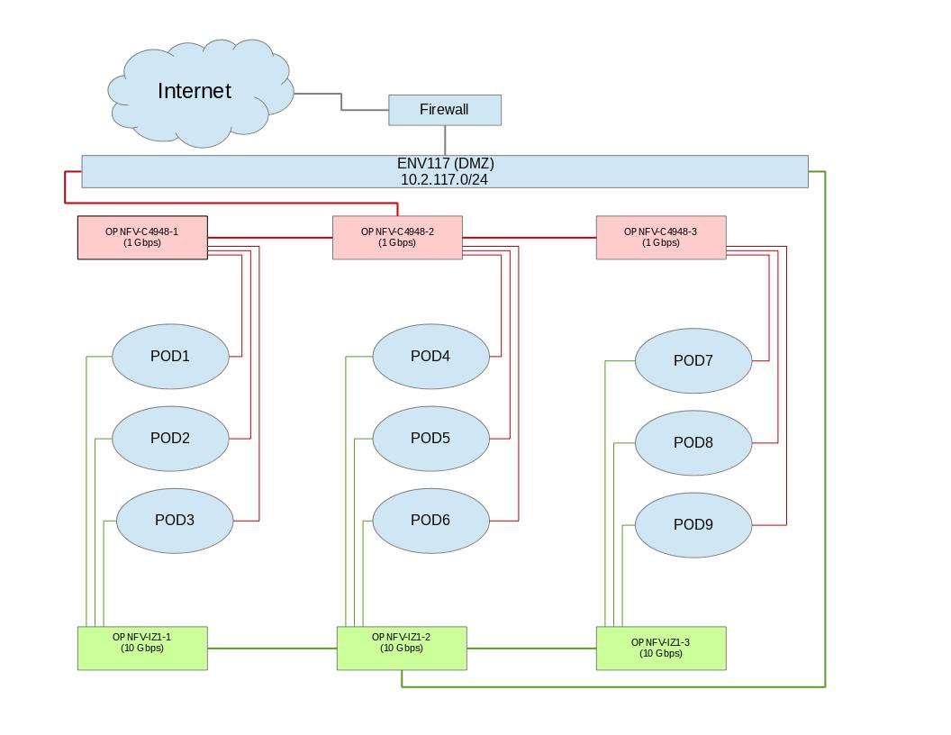

POD Specification Template
[pod_{d}escription:pharos-pod][pod_{d}escription::doc][pod_{d}escription:pod-specification-template]

Introduction
[pod_{d}escription:introduction] Add an summary of the POD usage (Project, CI stable, CI latest, dev/test, stand-alone servers, etc.)

Additional Requirements
[pod_{d}escription:additional-requirements] Describe any addional POD requirements beyond a standard Pharos compliant POD e.g. test equipment, shared usage, ...

Server Specifications
[pod_{d}escription:server-specifications] Jump Host
|L|L|L|L|L|L|L|L|L|L|L|
Hostname & Vendor & Model & Serial Number & CPUs & Memory & Local Storage & Lights-out network (IPMI): IP/MAC, U/P & 1GbE: NIC#/IP MAC/VLAN/Network & 10GbE: NIC#/IP MAC/VLAN/Network & Notes
jump & Dell & R730 & ABCDEF007 & E5-2699x2 & 64 GB & 240GB SSD 1 TB SATA & 10.10.10.10 00:1E:67:D4:36:9A root/root & IF0: 10.2.117.36 00:1E:67:4F:B7:B1 VLAN 984 Public IF1: 10.2.1.1 00:1E:67:4F:B7:B2 VLAN 201 Admin & IF2: 10.2.12.1 00:1E:67:4F:B7:B4 VLAN 202 Private IF3: 10.2.13.1 00:1E:67:4F:B7:B5 VLAN 203 Storage &
Compute Nodes
|L|L|L|L|L|L|L|L|L|L|L|
Hostname & Vendor & Model & Serial Number & CPUs & Memory & Local Storage & Lights-out network (IPMI): IP/MAC, U/P & 1GbE: NIC#/IP MAC/VLAN/Network & 10GbE: NIC#/IP MAC/VLAN/Network & Notes
node1 & & & & & & & & & &
node2 & & & & & & & & & &
node3 & & & & & & & & & &
node4 & & & & & & & & & &
node5 & & & & & & & & & &

VPN Users
[pod_{d}escription:vpn-users]
|L|L|L|L|L|
Name & Email & Project & Role & Notes
joe user & ju@gmail.com & Pharos & contributer & CI support

Firewall Rules
[pod_{d}escription:firewall-rules]
|L|L|L|
Port(s) & Service & Notes
22, 43, 80 & Jenkins CI &

POD Topology
[pod_{d}escription:pod-topology] Provide a diagram showing the network topology of the POD. Any security sensitive details should not be exposed publically and can be stored in the secure Pharos repo. The following diagram is an example only.
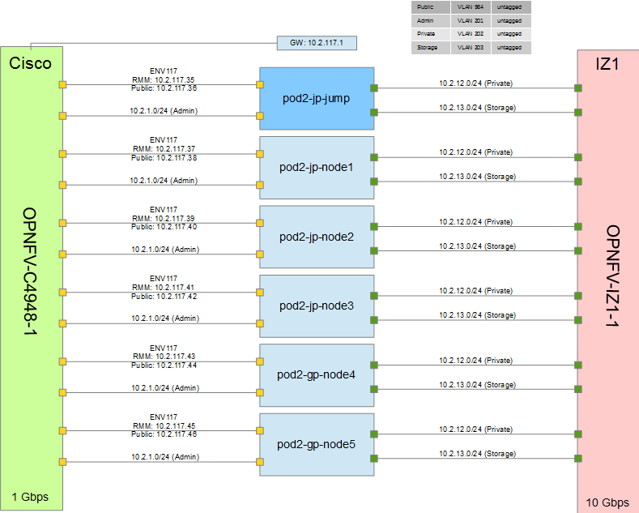

POD Inventory File
[inventory::doc][inventory:pod-inventory-file] The Common Inventory File provides a template for machine reabable input into every installer. For convenience the YAML file template currently resides in the Genesis Project repo. Refer to the following patch for further infomation https://gerrit.opnfv.org/gerrit/#/c/4079.

