VSPERF Design
OPNFV
January 21, 2016
[index::doc]

VSPERF Design Document
[vswitchperf_{d}esign:vsperf-design-document][vswitchperf_{d}esign::doc][vswitchperf_{d}esign:vsperf-design]

Intended Audience
[vswitchperf_{d}esign:intended-audience] This document is intended to aid those who want to modify the vsperf code. Or to extend it - for example to add support for new traffic generators, deployment scenarios and so on.

Usage
[vswitchperf_{d}esign:usage]

Example Command Lines
[vswitchperf_{d}esign:example-command-lines] List all the cli options:
\PYG{g+gp}{\PYGZdl{}} ./vsperf \PYGZhy{}h
Run all tests that have in their name - , etc.:
\PYG{g+gp}{\PYGZdl{}} ./vsperf \PYGZhy{}\PYGZhy{}tests \PYG{l+s+s1}{\PYGZsq{}tput\PYGZsq{}}
As above but override default configuration with settings in ‘10_custom.conf’. This is useful as modifying configuration directly in the configuration files in shows up as changes under git source control:
\PYG{g+gp}{\PYGZdl{}} ./vsperf \PYGZhy{}\PYGZhy{}conf\PYGZhy{}file\PYG{o}{=}\PYGZlt{}path\PYGZus{}to\PYGZus{}custom\PYGZus{}conf\PYGZgt{}/10\PYGZus{}custom.conf \PYGZhy{}\PYGZhy{}tests \PYG{l+s+s1}{\PYGZsq{}tput\PYGZsq{}}
Override specific test parameters. Useful for shortening the duration of tests for development purposes:
\PYG{g+gp}{\PYGZdl{}} ./vsperf \PYGZhy{}\PYGZhy{}test\PYGZhy{}params \PYG{l+s+s1}{\PYGZsq{}duration=10;rfc2544\PYGZus{}trials=1;pkt\PYGZus{}sizes=64\PYGZsq{}} \PYGZhy{}\PYGZhy{}tests \PYG{l+s+s1}{\PYGZsq{}pvp\PYGZus{}tput\PYGZsq{}}

Typical Test Sequence
[vswitchperf_{d}esign:typical-test-sequence] This is a typical flow of control for a test.
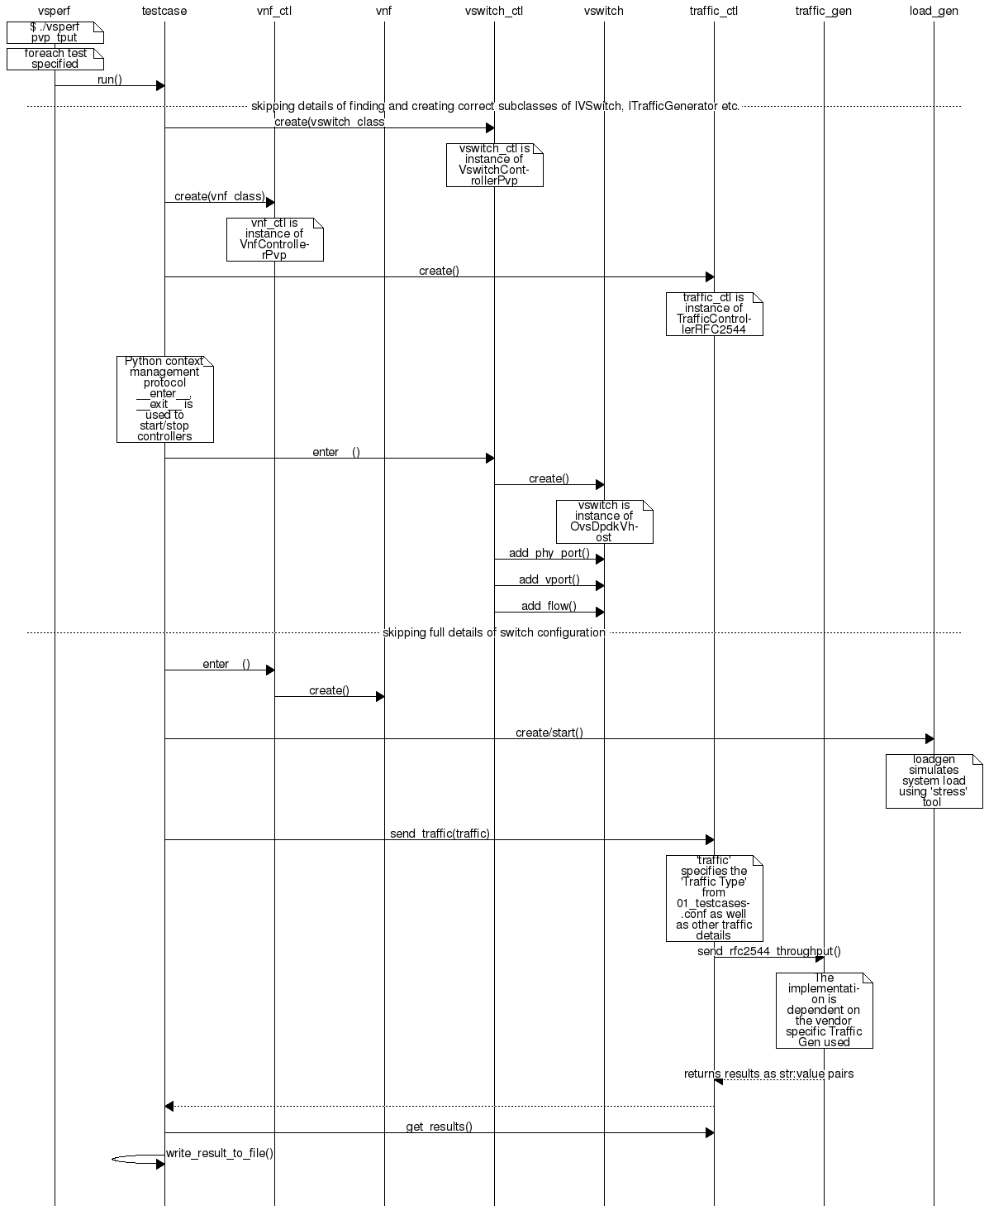

Configuration
[vswitchperf_{d}esign:configuration] The conf package contains the configuration files () for all system components, it also provides a object that exposes all of these settings.
Settings are not passed from component to component. Rather they are available globally to all components once they import the conf package.
\PYG{k+kn}{from} \PYG{n+nn}{conf} \PYG{k+kn}{import} \PYG{n}{settings}
\PYG{o}{.}\PYG{o}{.}\PYG{o}{.}
\PYG{n}{log\PYGZus{}file} \PYG{o}{=} \PYG{n}{settings}\PYG{o}{.}\PYG{n}{getValue}\PYG{p}{(}\PYG{l+s}{\PYGZsq{}}\PYG{l+s}{LOG\PYGZus{}FILE\PYGZus{}DEFAULT}\PYG{l+s}{\PYGZsq{}}\PYG{p}{)}
Settings files () are valid python code so can be set to complex types such as lists and dictionaries as well as scalar types:
\PYG{n}{first\PYGZus{}packet\PYGZus{}size} \PYG{o}{=} \PYG{n}{settings}\PYG{o}{.}\PYG{n}{getValue}\PYG{p}{(}\PYG{l+s}{\PYGZsq{}}\PYG{l+s}{PACKET\PYGZus{}SIZE\PYGZus{}LIST}\PYG{l+s}{\PYGZsq{}}\PYG{p}{)}\PYG{p}{[}\PYG{l+m+mi}{0}\PYG{p}{]}

Configuration Procedure and Precedence
[vswitchperf_{d}esign:configuration-procedure-and-precedence] Configuration files follow a strict naming convention that allows them to be processed in a specific order. All the .conf files are named , where NN is a decimal number. The files are processed in order from 00_name.conf to 99_name.conf so that if the name setting is given in both a lower and higher numbered conf file then the higher numbered file is the effective setting as it is processed after the setting in the lower numbered file.
The values in the file specified by takes precedence over all the other configuration files and does not have to follow the naming convention.

Other Configuration
[vswitchperf_{d}esign:other-configuration] also loads configuration from the command line and from the environment.

VM, vSwitch, Traffic Generator Independence
[vswitchperf_{d}esign:vm-vswitch-traffic-generator-independence] VSPERF supports different vSwithes, Traffic Generators and VNFs by using standard object-oriented polymorphism:
- Support for vSwitches is implemented by a class inheriting from IVSwitch.
- Support for Traffic Generators is implemented by a class inheriting from ITrafficGenerator.
- Support for VNF is implemented by a class inheriting from IVNF.
By dealing only with the abstract interfaces the core framework can support many implementations of different vSwitches, Traffic Generators and VNFs.

IVSwitch
[vswitchperf_{d}esign:ivswitch]
\PYG{k}{class} \PYG{n+nc}{IVSwitch}\PYG{p}{:}
\PYG{n}{start}\PYG{p}{(}\PYG{n+nb+bp}{self}\PYG{p}{)}
\PYG{n}{stop}\PYG{p}{(}\PYG{n+nb+bp}{self}\PYG{p}{)}
\PYG{n}{add\PYGZus{}switch}\PYG{p}{(}\PYG{n}{switch\PYGZus{}name}\PYG{p}{)}
\PYG{n}{del\PYGZus{}switch}\PYG{p}{(}\PYG{n}{switch\PYGZus{}name}\PYG{p}{)}
\PYG{n}{add\PYGZus{}phy\PYGZus{}port}\PYG{p}{(}\PYG{n}{switch\PYGZus{}name}\PYG{p}{)}
\PYG{n}{add\PYGZus{}vport}\PYG{p}{(}\PYG{n}{switch\PYGZus{}name}\PYG{p}{)}
\PYG{n}{get\PYGZus{}ports}\PYG{p}{(}\PYG{n}{switch\PYGZus{}name}\PYG{p}{)}
\PYG{n}{del\PYGZus{}port}\PYG{p}{(}\PYG{n}{switch\PYGZus{}name}\PYG{p}{,} \PYG{n}{port\PYGZus{}name}\PYG{p}{)}
\PYG{n}{add\PYGZus{}flow}\PYG{p}{(}\PYG{n}{switch\PYGZus{}name}\PYG{p}{,} \PYG{n}{flow}\PYG{p}{)}
\PYG{n}{del\PYGZus{}flow}\PYG{p}{(}\PYG{n}{switch\PYGZus{}name}\PYG{p}{,} \PYG{n}{flow}\PYG{o}{=}\PYG{n+nb+bp}{None}\PYG{p}{)}

ITrafficGenerator
[vswitchperf_{d}esign:itrafficgenerator]
\PYG{k}{class} \PYG{n+nc}{ITrafficGenerator}\PYG{p}{:}
\PYG{n}{connect}\PYG{p}{(}\PYG{p}{)}
\PYG{n}{disconnect}\PYG{p}{(}\PYG{p}{)}

\PYG{n}{send\PYGZus{}burst\PYGZus{}traffic}\PYG{p}{(}\PYG{n}{traffic}\PYG{p}{,} \PYG{n}{numpkts}\PYG{p}{,} \PYG{n}{time}\PYG{p}{,} \PYG{n}{framerate}\PYG{p}{)}

\PYG{n}{send\PYGZus{}cont\PYGZus{}traffic}\PYG{p}{(}\PYG{n}{traffic}\PYG{p}{,} \PYG{n}{time}\PYG{p}{,} \PYG{n}{framerate}\PYG{p}{)}
\PYG{n}{start\PYGZus{}cont\PYGZus{}traffic}\PYG{p}{(}\PYG{n}{traffic}\PYG{p}{,} \PYG{n}{time}\PYG{p}{,} \PYG{n}{framerate}\PYG{p}{)}
\PYG{n}{stop\PYGZus{}cont\PYGZus{}traffic}\PYG{p}{(}\PYG{n+nb+bp}{self}\PYG{p}{)}\PYG{p}{:}

\PYG{n}{send\PYGZus{}rfc2544\PYGZus{}throughput}\PYG{p}{(}\PYG{n}{traffic}\PYG{p}{,} \PYG{n}{trials}\PYG{p}{,} \PYG{n}{duration}\PYG{p}{,} \PYG{n}{lossrate}\PYG{p}{)}
\PYG{n}{start\PYGZus{}rfc2544\PYGZus{}throughput}\PYG{p}{(}\PYG{n}{traffic}\PYG{p}{,} \PYG{n}{trials}\PYG{p}{,} \PYG{n}{duration}\PYG{p}{,} \PYG{n}{lossrate}\PYG{p}{)}
\PYG{n}{wait\PYGZus{}rfc2544\PYGZus{}throughput}\PYG{p}{(}\PYG{n+nb+bp}{self}\PYG{p}{)}

\PYG{n}{send\PYGZus{}rfc2544\PYGZus{}back2back}\PYG{p}{(}\PYG{n}{traffic}\PYG{p}{,} \PYG{n}{trials}\PYG{p}{,} \PYG{n}{duration}\PYG{p}{,} \PYG{n}{lossrate}\PYG{p}{)}
\PYG{n}{start\PYGZus{}rfc2544\PYGZus{}back2back}\PYG{p}{(}\PYG{n}{traffic}\PYG{p}{,} \PYG{p}{,} \PYG{n}{trials}\PYG{p}{,} \PYG{n}{duration}\PYG{p}{,} \PYG{n}{lossrate}\PYG{p}{)}
\PYG{n}{wait\PYGZus{}rfc2544\PYGZus{}back2back}\PYG{p}{(}\PYG{p}{)}
Note blocks whereas does not and must be followed by a subsequent call to .

IVnf
[vswitchperf_{d}esign:ivnf]
\PYG{k}{class} \PYG{n+nc}{IVnf}\PYG{p}{:}
\PYG{n}{start}\PYG{p}{(}\PYG{n}{memory}\PYG{p}{,} \PYG{n}{cpus}\PYG{p}{,}
\PYG{n}{monitor\PYGZus{}path}\PYG{p}{,} \PYG{n}{shared\PYGZus{}path\PYGZus{}host}\PYG{p}{,}
\PYG{n}{shared\PYGZus{}path\PYGZus{}guest}\PYG{p}{,} \PYG{n}{guest\PYGZus{}prompt}\PYG{p}{)}
\PYG{n}{stop}\PYG{p}{(}\PYG{p}{)}
\PYG{n}{execute}\PYG{p}{(}\PYG{n}{command}\PYG{p}{)}
\PYG{n}{wait}\PYG{p}{(}\PYG{n}{guest\PYGZus{}prompt}\PYG{p}{)}
\PYG{n}{execute\PYGZus{}and\PYGZus{}wait} \PYG{p}{(}\PYG{n}{command}\PYG{p}{)}

Controllers
[vswitchperf_{d}esign:controllers] Controllers are used in conjunction with abstract interfaces as way of decoupling the control of vSwtiches, VNFs and TrafficGenerators from other components.
The controlled classes provide basic primitive operations. The Controllers sequence and co-ordinate these primitive operation in to useful actions. For instance the vswitch_controller_PVP can be used to bring any vSwitch (that implements the primitives defined in IVSwitch) into the configuration required by the Phy-to-Phy Deployment Scenario.
In order to support a new vSwitch only a new implementation of IVSwitch needs be created for the new vSwitch to be capable of fulfilling all the Deployment Scenarios provided for by existing or future vSwitch Controllers.
Similarly if a new Deployment Scenario is required it only needs to be written once as a new vSwitch Controller and it will immediately be capable of controlling all existing and future vSwitches in to that Deployment Scenario.
Similarly the Traffic Controllers can be used to co-ordinate basic operations provided by implementers of ITrafficGenerator to provide useful tests. Though traffic generators generally already implement full test cases i.e. they both generate suitable traffic and analyse returned traffic in order to implement a test which has typically been predefined in an RFC document. However the Traffic Controller class allows for the possibility of further enhancement - such as iterating over tests for various packet sizes or creating new tests.

Traffic Controller’s Role
[vswitchperf_{d}esign:traffic-controller-s-role] 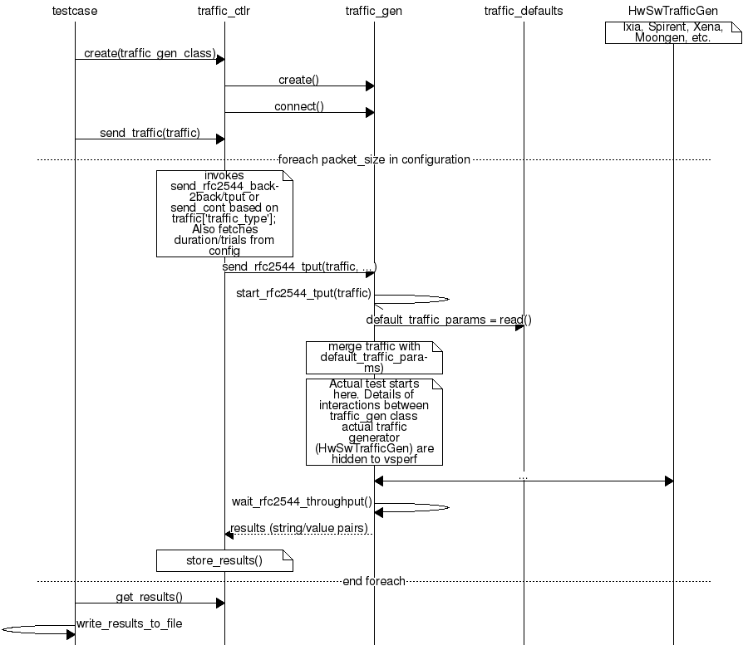

Loader & Component Factory
[vswitchperf_{d}esign:loader-component-factory] The working of the Loader package (which is responsible for finding arbitrary classes based on configuration data) and the Component Factory which is responsible for choosing the correct class for a particular situation - e.g. Deployment Scenario can be seen in this diagram.
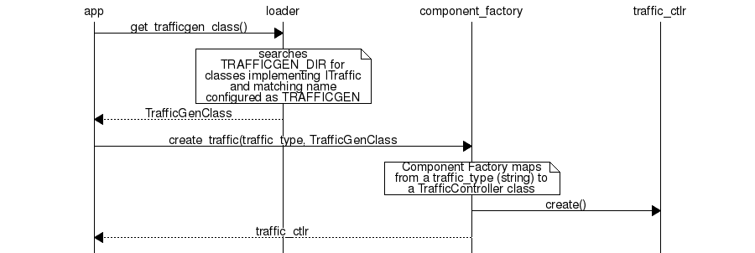

Routing Tables
[vswitchperf_{d}esign:routing-tables] Vsperf uses a standard set of routing tables in order to allow tests to easily mix and match Deployment Scenarios (PVP, P2P topology), Tuple Matching and Frame Modification requirements.
\PYG{g+go}{+\PYGZhy{}\PYGZhy{}\PYGZhy{}\PYGZhy{}\PYGZhy{}\PYGZhy{}\PYGZhy{}\PYGZhy{}\PYGZhy{}\PYGZhy{}\PYGZhy{}\PYGZhy{}\PYGZhy{}\PYGZhy{}+}
\PYG{g+go}{\textbar{} \textbar{}}
\PYG{g+go}{\textbar{} Table 0 \textbar{} table\PYGZsh{}0 \PYGZhy{} Match table. Flows designed to force 5 \PYGZam{} 10}
\PYG{g+go}{\textbar{} \textbar{} tuple matches go here.}
\PYG{g+go}{\textbar{} \textbar{}}
\PYG{g+go}{+\PYGZhy{}\PYGZhy{}\PYGZhy{}\PYGZhy{}\PYGZhy{}\PYGZhy{}\PYGZhy{}\PYGZhy{}\PYGZhy{}\PYGZhy{}\PYGZhy{}\PYGZhy{}\PYGZhy{}\PYGZhy{}+}
\PYG{g+go}{ \textbar{}}
\PYG{g+go}{ \textbar{}}
\PYG{g+go}{ v}
\PYG{g+go}{+\PYGZhy{}\PYGZhy{}\PYGZhy{}\PYGZhy{}\PYGZhy{}\PYGZhy{}\PYGZhy{}\PYGZhy{}\PYGZhy{}\PYGZhy{}\PYGZhy{}\PYGZhy{}\PYGZhy{}\PYGZhy{}+ table\PYGZsh{}1 \PYGZhy{} Routing table. Flows to route packets between}
\PYG{g+go}{\textbar{} \textbar{} ports goes here.}
\PYG{g+go}{\textbar{} Table 1 \textbar{} The chosen port is communicated to subsequent tables by}
\PYG{g+go}{\textbar{} \textbar{} setting the metadata value to the egress port number.}
\PYG{g+go}{\textbar{} \textbar{} Generally this table is set\PYGZhy{}up by by the}
\PYG{g+go}{+\PYGZhy{}\PYGZhy{}\PYGZhy{}\PYGZhy{}\PYGZhy{}\PYGZhy{}\PYGZhy{}\PYGZhy{}\PYGZhy{}\PYGZhy{}\PYGZhy{}\PYGZhy{}\PYGZhy{}\PYGZhy{}+ vSwitchController.}
\PYG{g+go}{ \textbar{}}
\PYG{g+go}{ \textbar{}}
\PYG{g+go}{ v}
\PYG{g+go}{+\PYGZhy{}\PYGZhy{}\PYGZhy{}\PYGZhy{}\PYGZhy{}\PYGZhy{}\PYGZhy{}\PYGZhy{}\PYGZhy{}\PYGZhy{}\PYGZhy{}\PYGZhy{}\PYGZhy{}\PYGZhy{}+ table\PYGZsh{}2 \PYGZhy{} Frame modification table. Frame modification}
\PYG{g+go}{\textbar{} \textbar{} flow rules are isolated in this table so that they can}
\PYG{g+go}{\textbar{} Table 2 \textbar{} be turned on or off without affecting the routing or}
\PYG{g+go}{\textbar{} \textbar{} tuple\PYGZhy{}matching flow rules. This allows the frame}
\PYG{g+go}{\textbar{} \textbar{} modification and tuple matching required by the tests}
\PYG{g+go}{\textbar{} \textbar{} in the VSWITCH PERFORMANCE FOR TELCO NFV test}
\PYG{g+go}{+\PYGZhy{}\PYGZhy{}\PYGZhy{}\PYGZhy{}\PYGZhy{}\PYGZhy{}\PYGZhy{}\PYGZhy{}\PYGZhy{}\PYGZhy{}\PYGZhy{}\PYGZhy{}\PYGZhy{}\PYGZhy{}+ specification to be independent of the Deployment}
\PYG{g+go}{ \textbar{} Scenario set up by the vSwitchController.}
\PYG{g+go}{ \textbar{}}
\PYG{g+go}{ v}
\PYG{g+go}{+\PYGZhy{}\PYGZhy{}\PYGZhy{}\PYGZhy{}\PYGZhy{}\PYGZhy{}\PYGZhy{}\PYGZhy{}\PYGZhy{}\PYGZhy{}\PYGZhy{}\PYGZhy{}\PYGZhy{}\PYGZhy{}+}
\PYG{g+go}{\textbar{} \textbar{}}
\PYG{g+go}{\textbar{} Table 3 \textbar{} table\PYGZsh{}3 \PYGZhy{} Egress table. Egress packets on the ports}
\PYG{g+go}{\textbar{} \textbar{} setup in Table 1.}
\PYG{g+go}{+\PYGZhy{}\PYGZhy{}\PYGZhy{}\PYGZhy{}\PYGZhy{}\PYGZhy{}\PYGZhy{}\PYGZhy{}\PYGZhy{}\PYGZhy{}\PYGZhy{}\PYGZhy{}\PYGZhy{}\PYGZhy{}+}

