Doctor Platform Overview
OPNFV
February 25, 2016
[index::doc]

Doctor platform components and features
[index:doctor-platform-overview][index:doctor-platform-components-and-features] https://wiki.opnfv.org/doctor

Features
[index:features] Doctor platform, as of Brahmaputra release, provides the two features:
- Immediate Notification
- Consistent resource state awareness (Compute/host-down)
These features enable high availability of Network Services on top of the virtualized infrastructure. Immediate notification allows VNF managers (VNFM) to process recovery actions promptly once a failure has occurred. Consistency of resource state is necessary to properly execute recovery actions properly in the VIM.

Components
[index:components] Doctor platform, as of Brahmaputra release, consists of the following components:
- OpenStack Compute (Nova)
- OpenStack Telemetry (Ceilometer)
- OpenStack Alarming (Aodh)
- Doctor Inspector
- Doctor Monitor
note
Note:
Doctor Inspector and Monitor are sample implementation for reference.
You can see an overview of the Doctor platform and how components interact in .
[htbp]
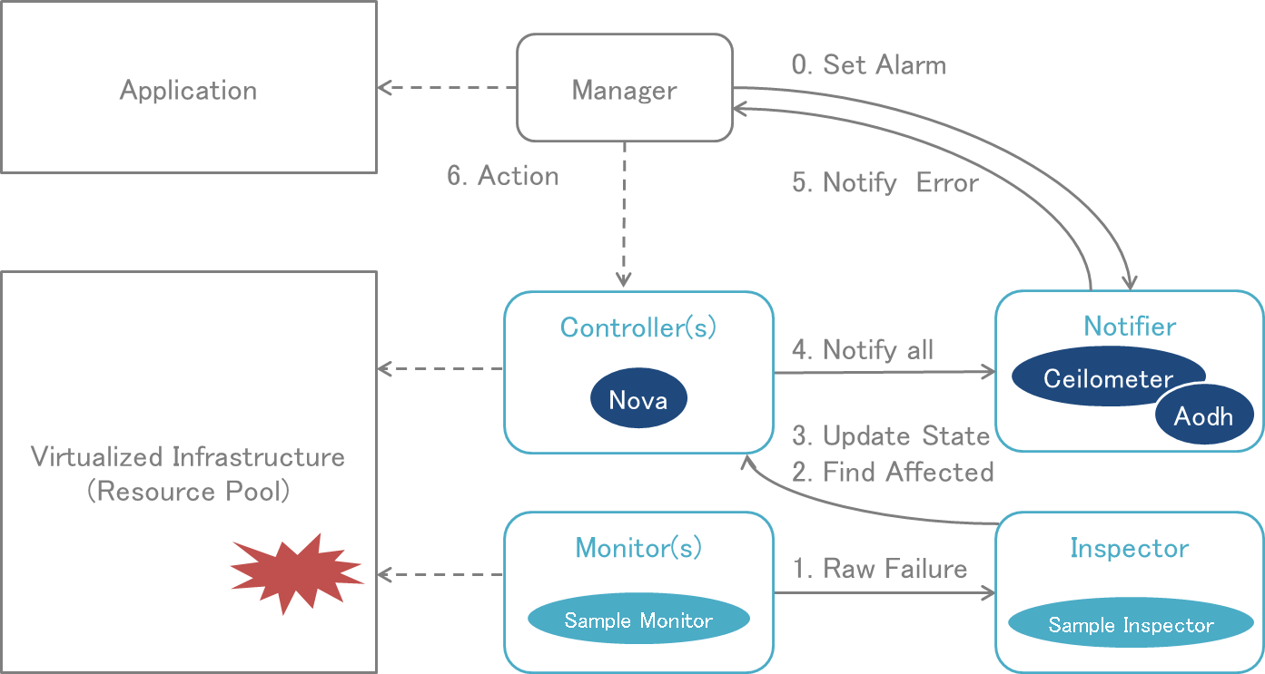 [index:figure-p1]
Detailed information on the Doctor architecture can be found in the Doctor requirements documentation: http://artifacts.opnfv.org/doctor/docs/requirements/05-implementation.html

